**Unreal Engine Pinball**

Name: Sanket DharmendraKumar Saboo Rollno: 1911112

Comps-B

**Component: Bonus Region**

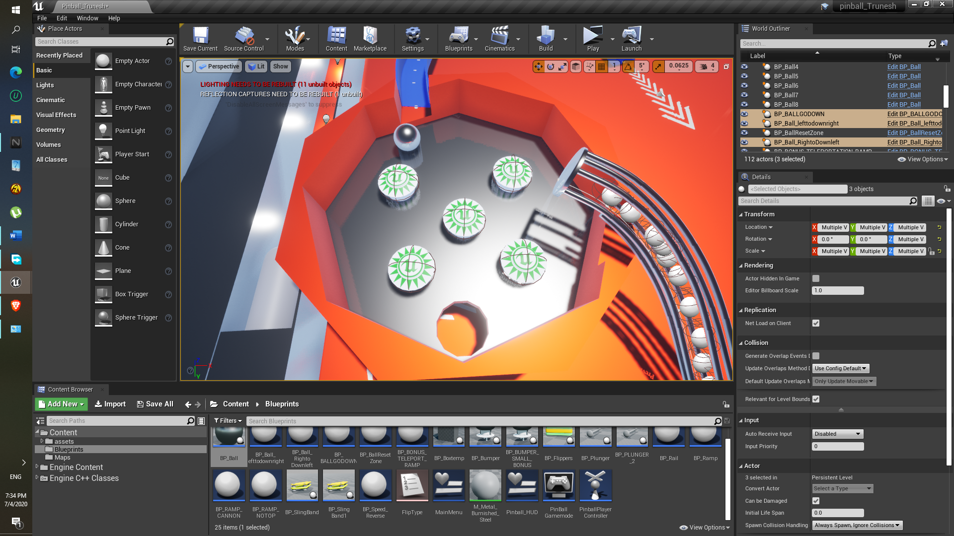

Approach:

1. As shown in the lecture video, bonus region has to be in circular shape and having multiple sides, that’s why cylinders are used.
2. One Cylinder is used as base and another is subtractive as shown in picture below to add the same look.

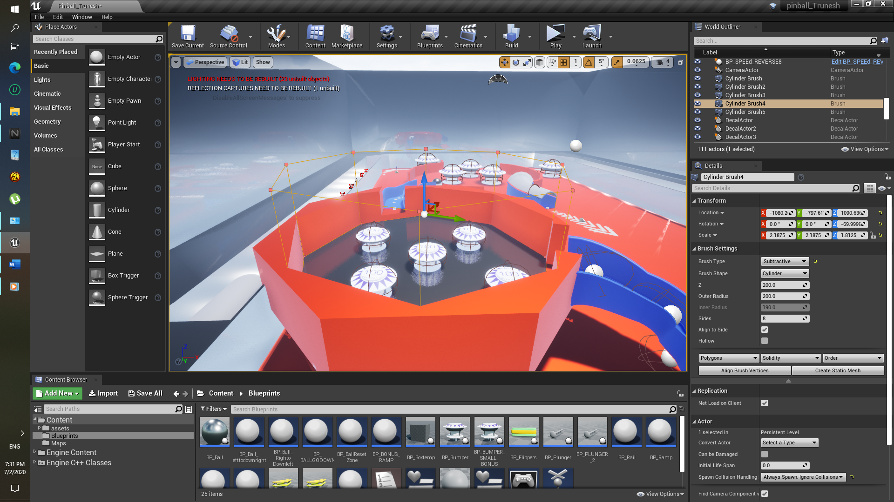

1. No. of sides for Subtractive and Additive for both cylinder Geometry is selected as 8.
2. Also, one more small Subtractive cylinder is placed where ball can go through it in the bottom Cylinder.
3. Right hand side of the bonus region, Rail is used for the ball to go in upward direction.

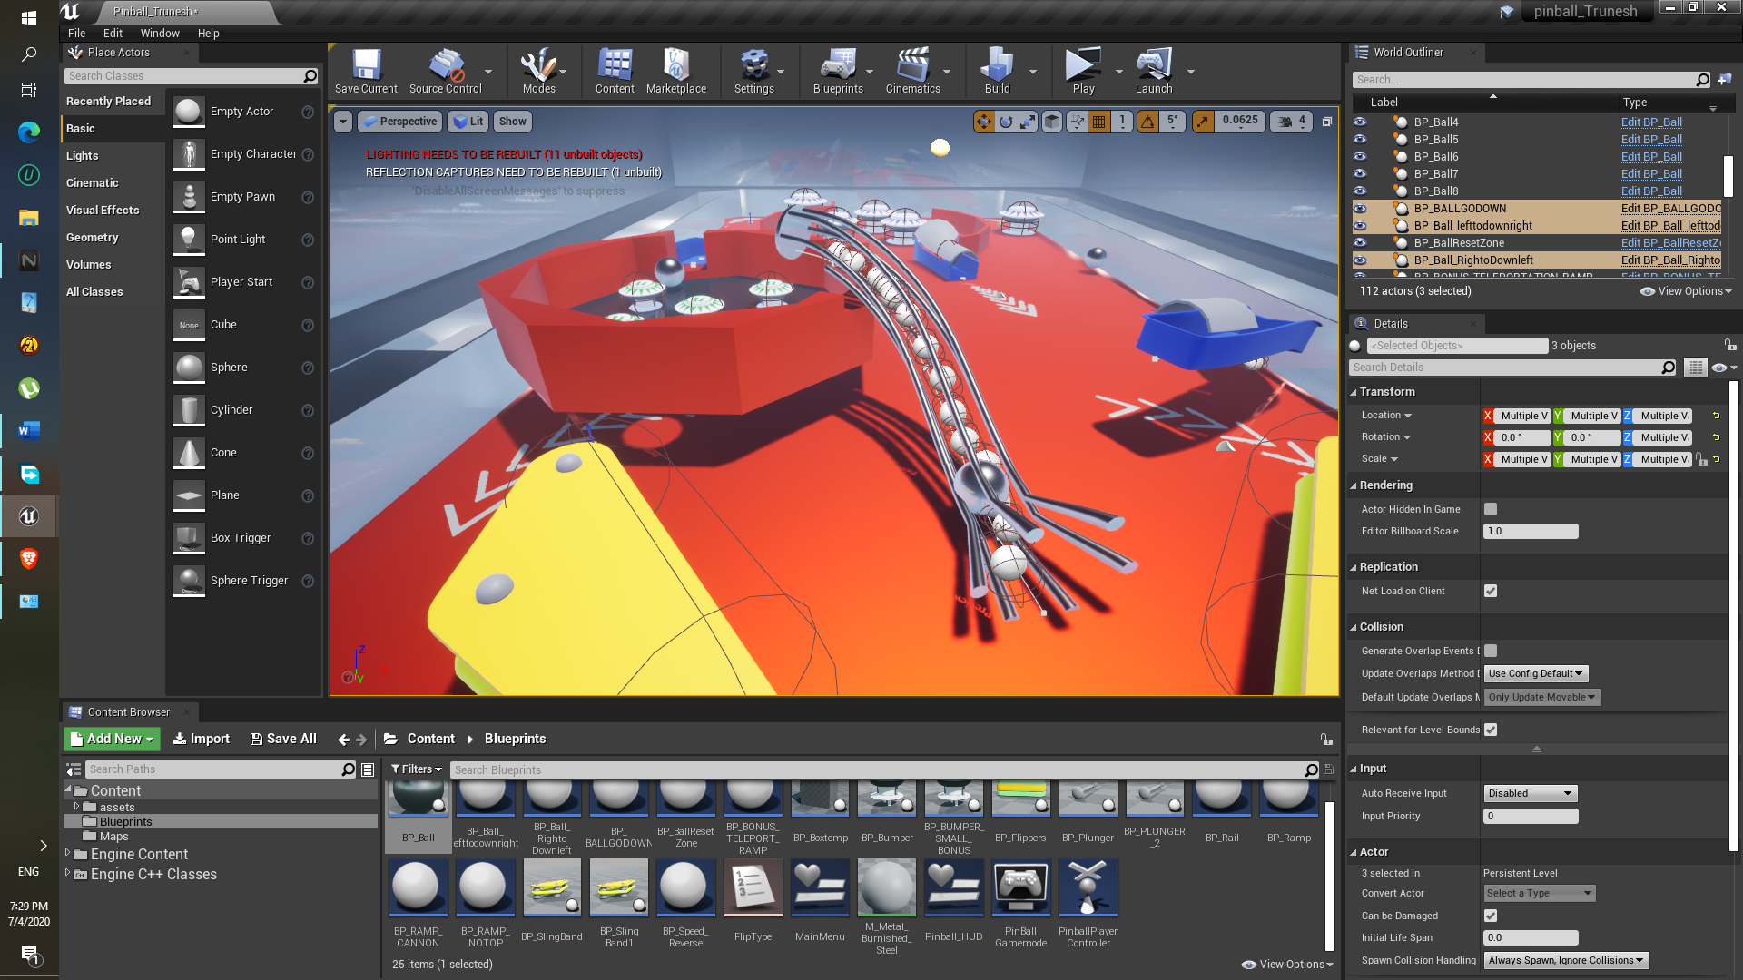

1. Also another blueprint class is used to make ball go in reverse direction named as “BP_Speed_Reverse” , as you can see it is placed inside the Rail.

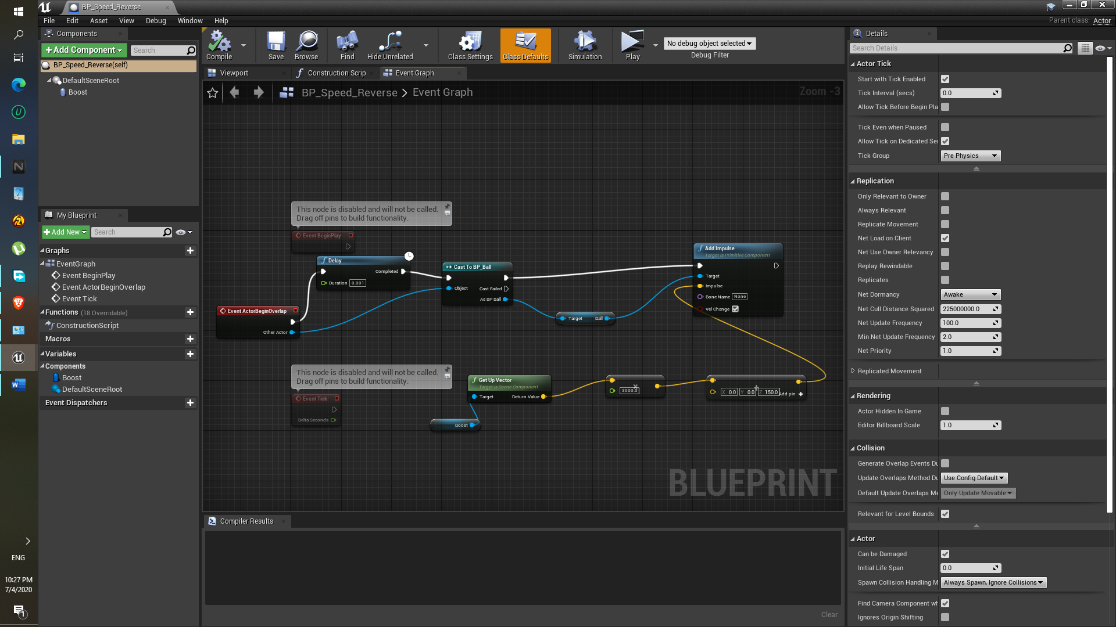

**Component: Bumper ( Small Bumpers inside the Bonus region)**

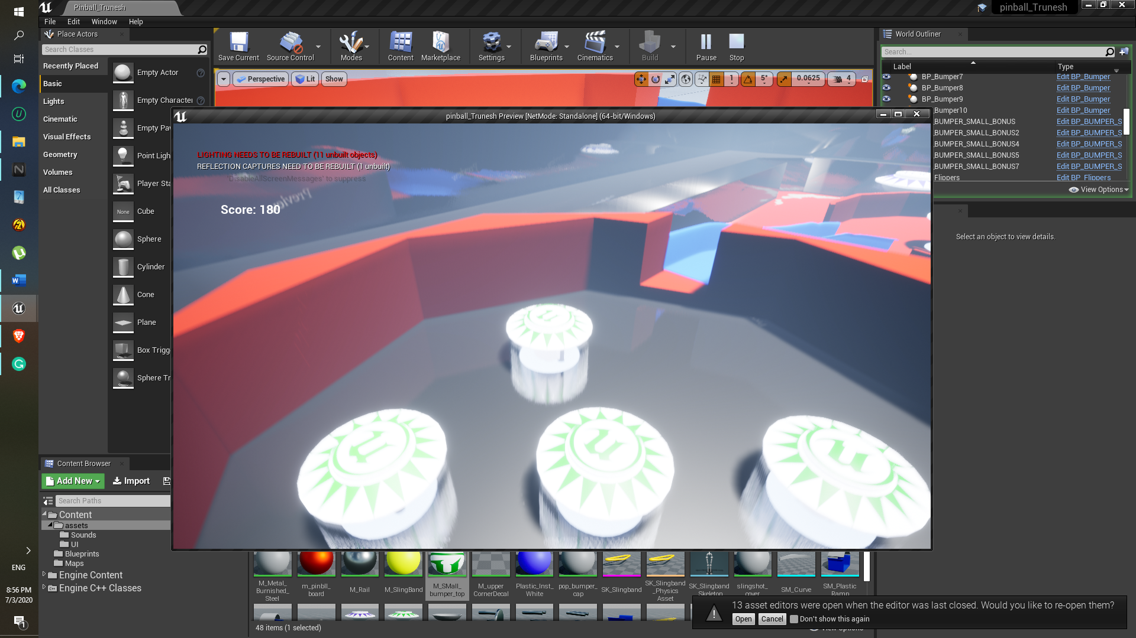

1. They are made using the Bumper(Large Bumper) reference.
2. In this graph the get actor location , that is bumper itself and the ball actor location is taken , so that the we should get the vector using ‘Get unit Direction(Vector)’ , like a perpendicular from the bumper position to the Ball.
3. Cast BP_Ball is used to check whether or not the ball is in the overlapping region.

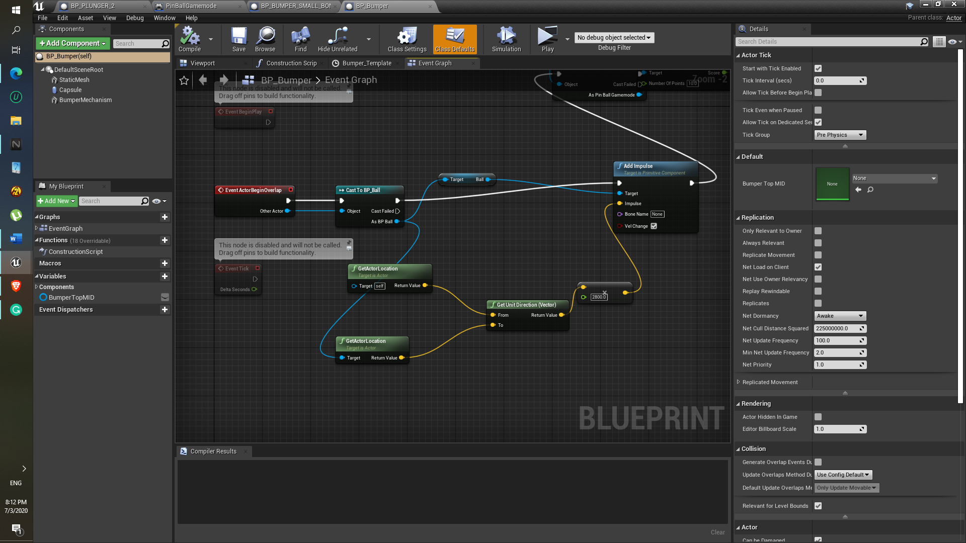

1. Also for the movement of the bumper mechanism again lerp is used, ‘set relative location is also work’ (Here I used ‘set relative location and rotation’ well if I don’t specify rotation it works same as set relative location)

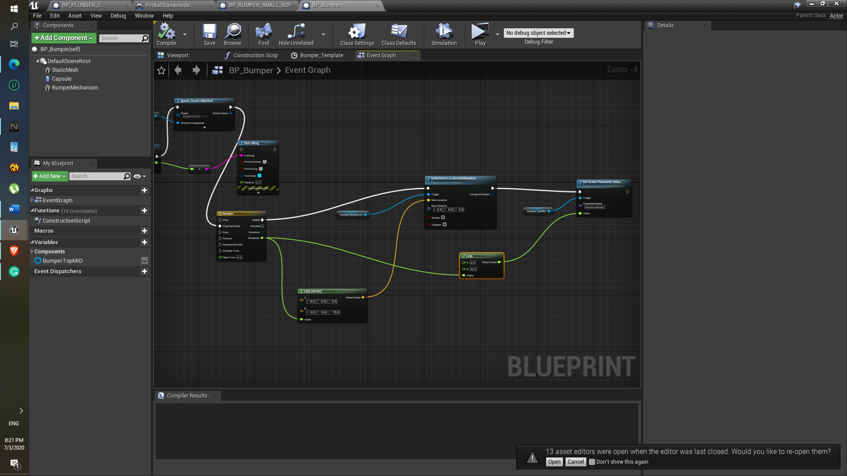

1. One change I had to made for the Bumper view port, because ball couldn’t touch its collision so I just increase it ‘collision overlap’

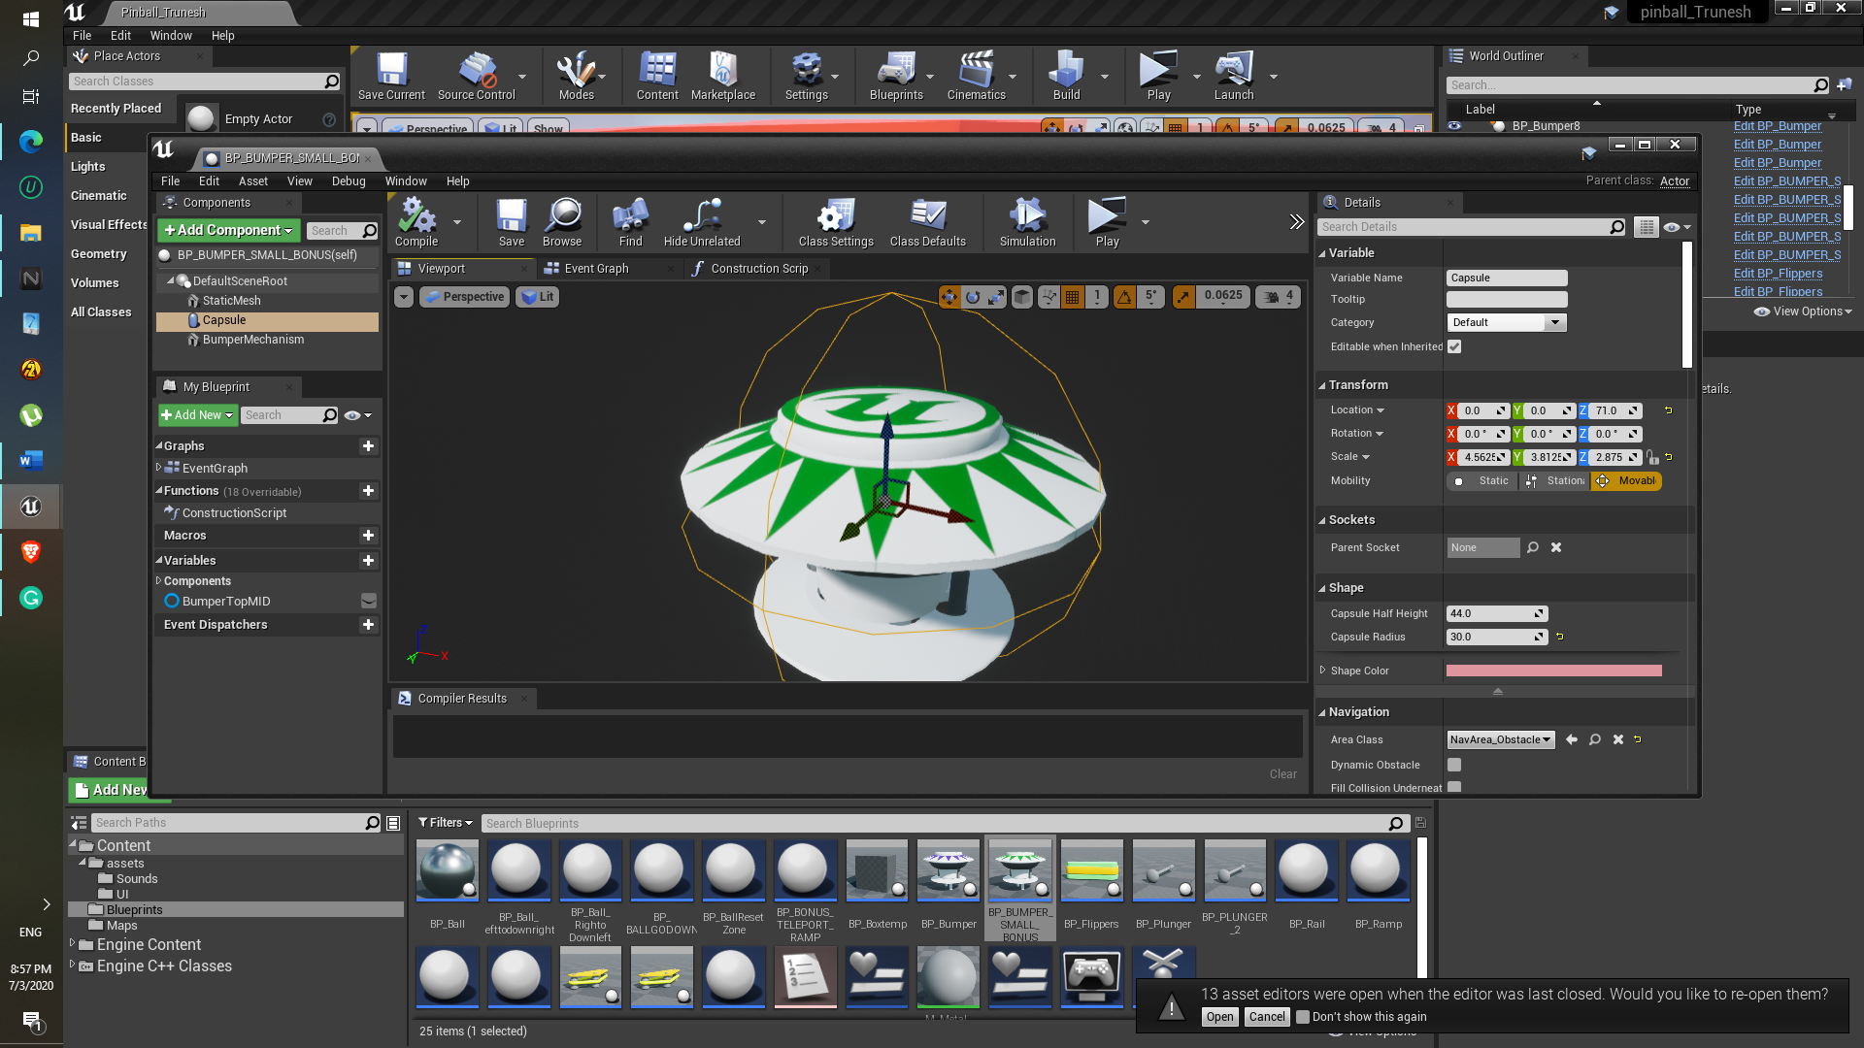

1. As for the material, texture was imported from the pinball asset.
2. Sounds are added using ‘Spawn Sound 2D’

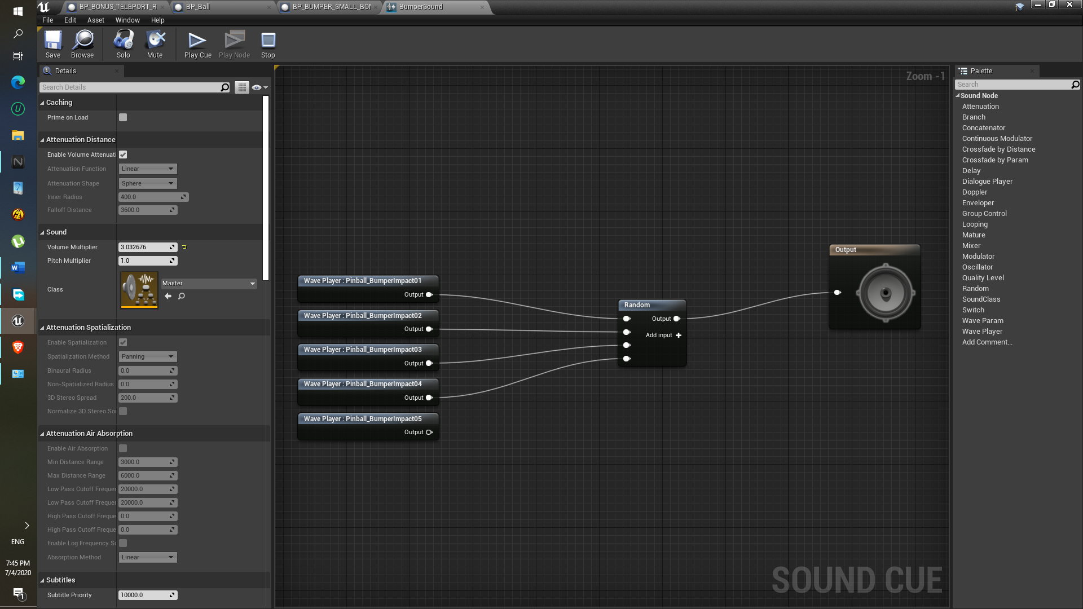

**Component: Central Region**

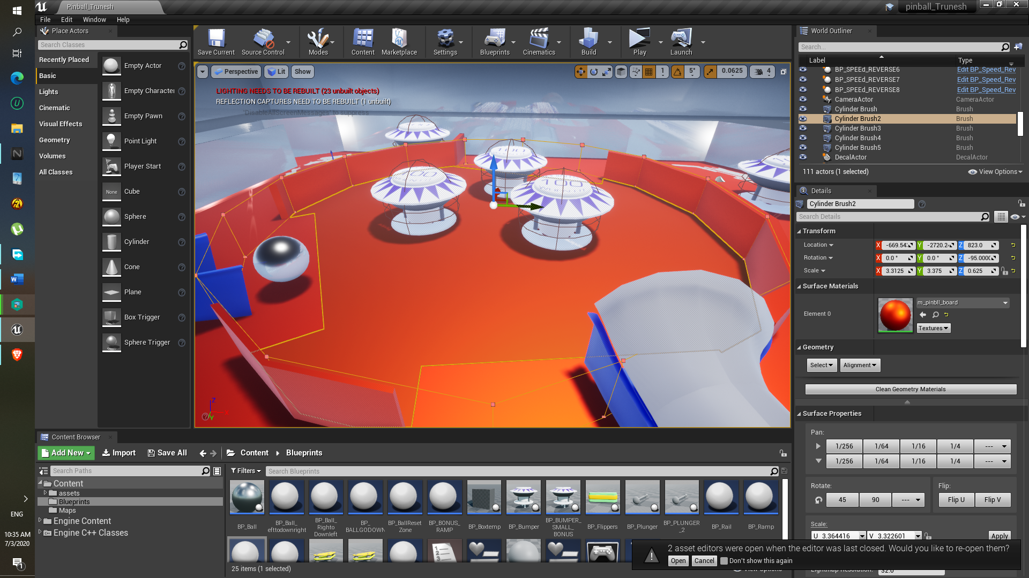

Approach:

1. This region is also made using the Two Cylinders geometry brush , i.e. one is additive which is attach to the surface and one is subtractive as shown in above image.
2. For that gap around the Cannon and the left side ramp , the Subtractive box geometry is used.

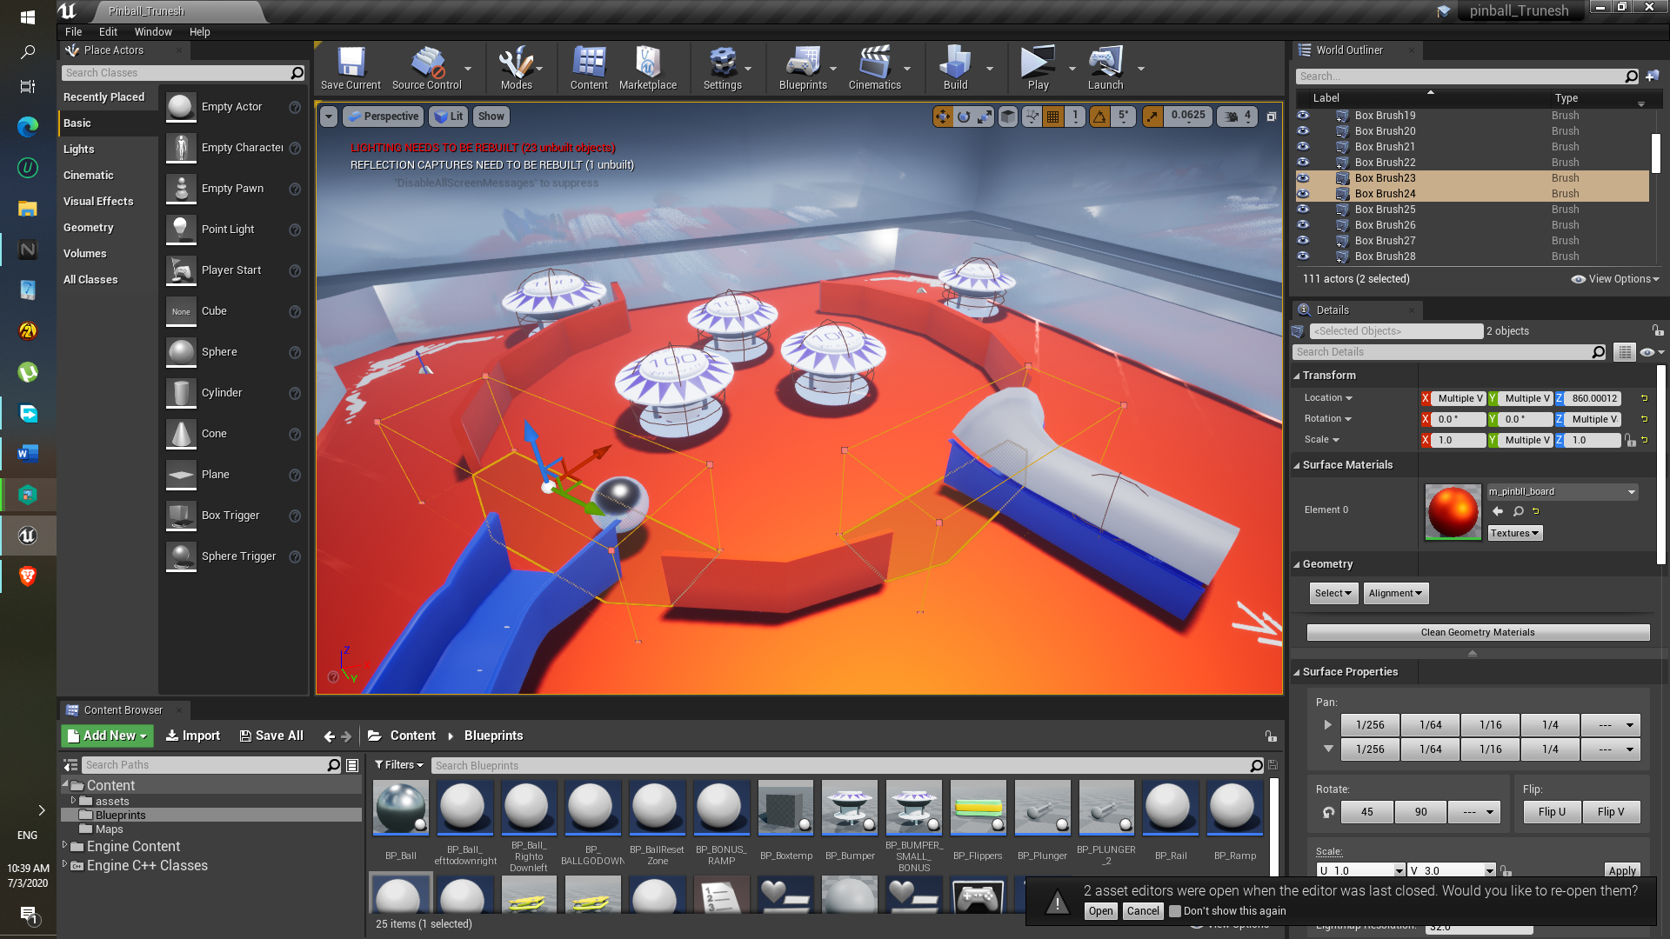

1. As for the Bumpers they are the same BP_Bumper, but the impulse reduced very slightly, so that ball should be on ground as shown in above image.
2. As for that top left bumper and right hand side of that bumper is the Geometry is box scale down to flat wall .

Difficulty: None

**Component: Cannon**

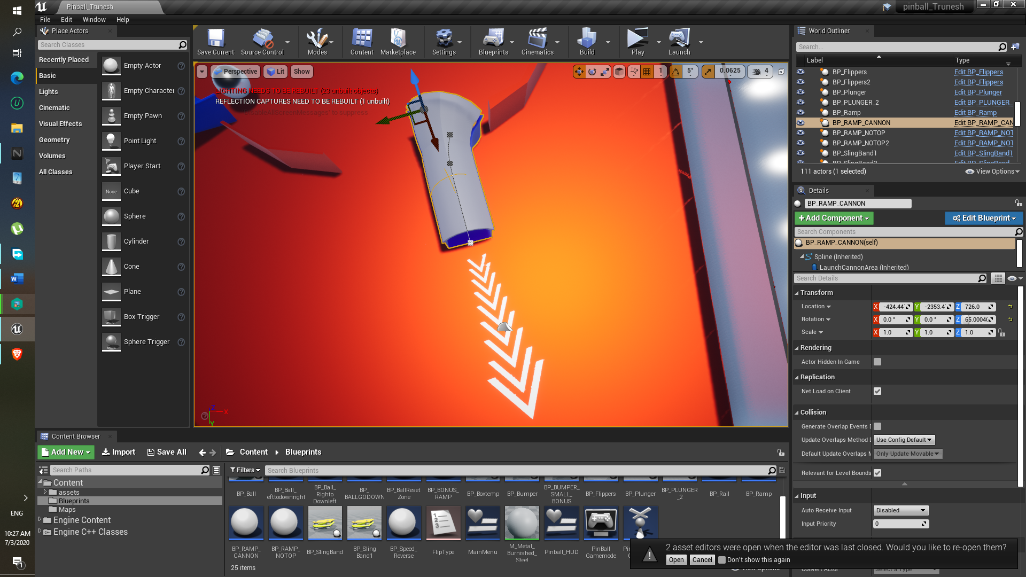

Approach:

1. This is also done using the rail blueprint.
2. Added the Collision at the end part of the ramp so that if ball pass through that collision, the quick boost will be generated.
3. In the collision part, the following components are added, here get right vector so that ball can go to that particular direction.
4. That Decal is just copied as it is from the existing once that I created.

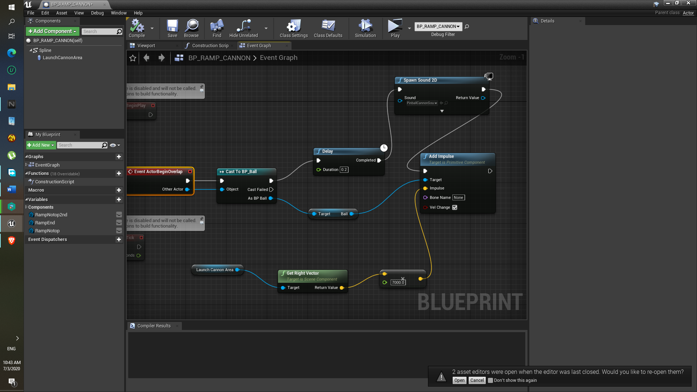

Difficulty:

Having trouble with creating ramp or rail of my own, I did not understand properly, here I thing should have created the Ramp using only the End part mesh (EX. RAMP_END ) and only two points, but in the blueprint I used the same Rail Blueprint , it’s the same Rail blueprint.

**Component: Bonus Spawn Teleportation**

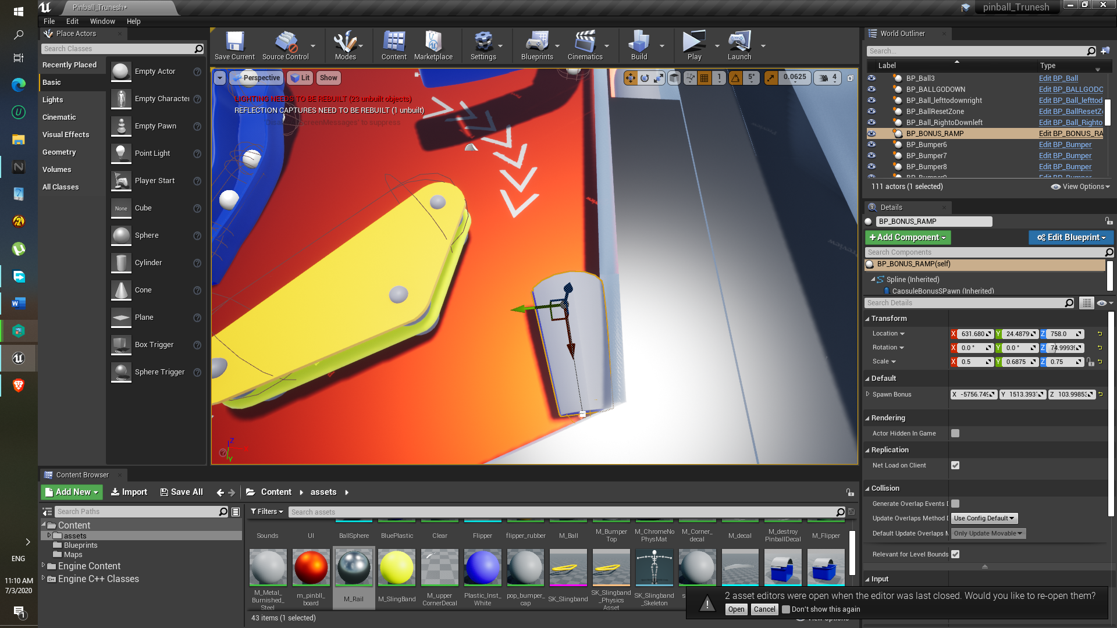

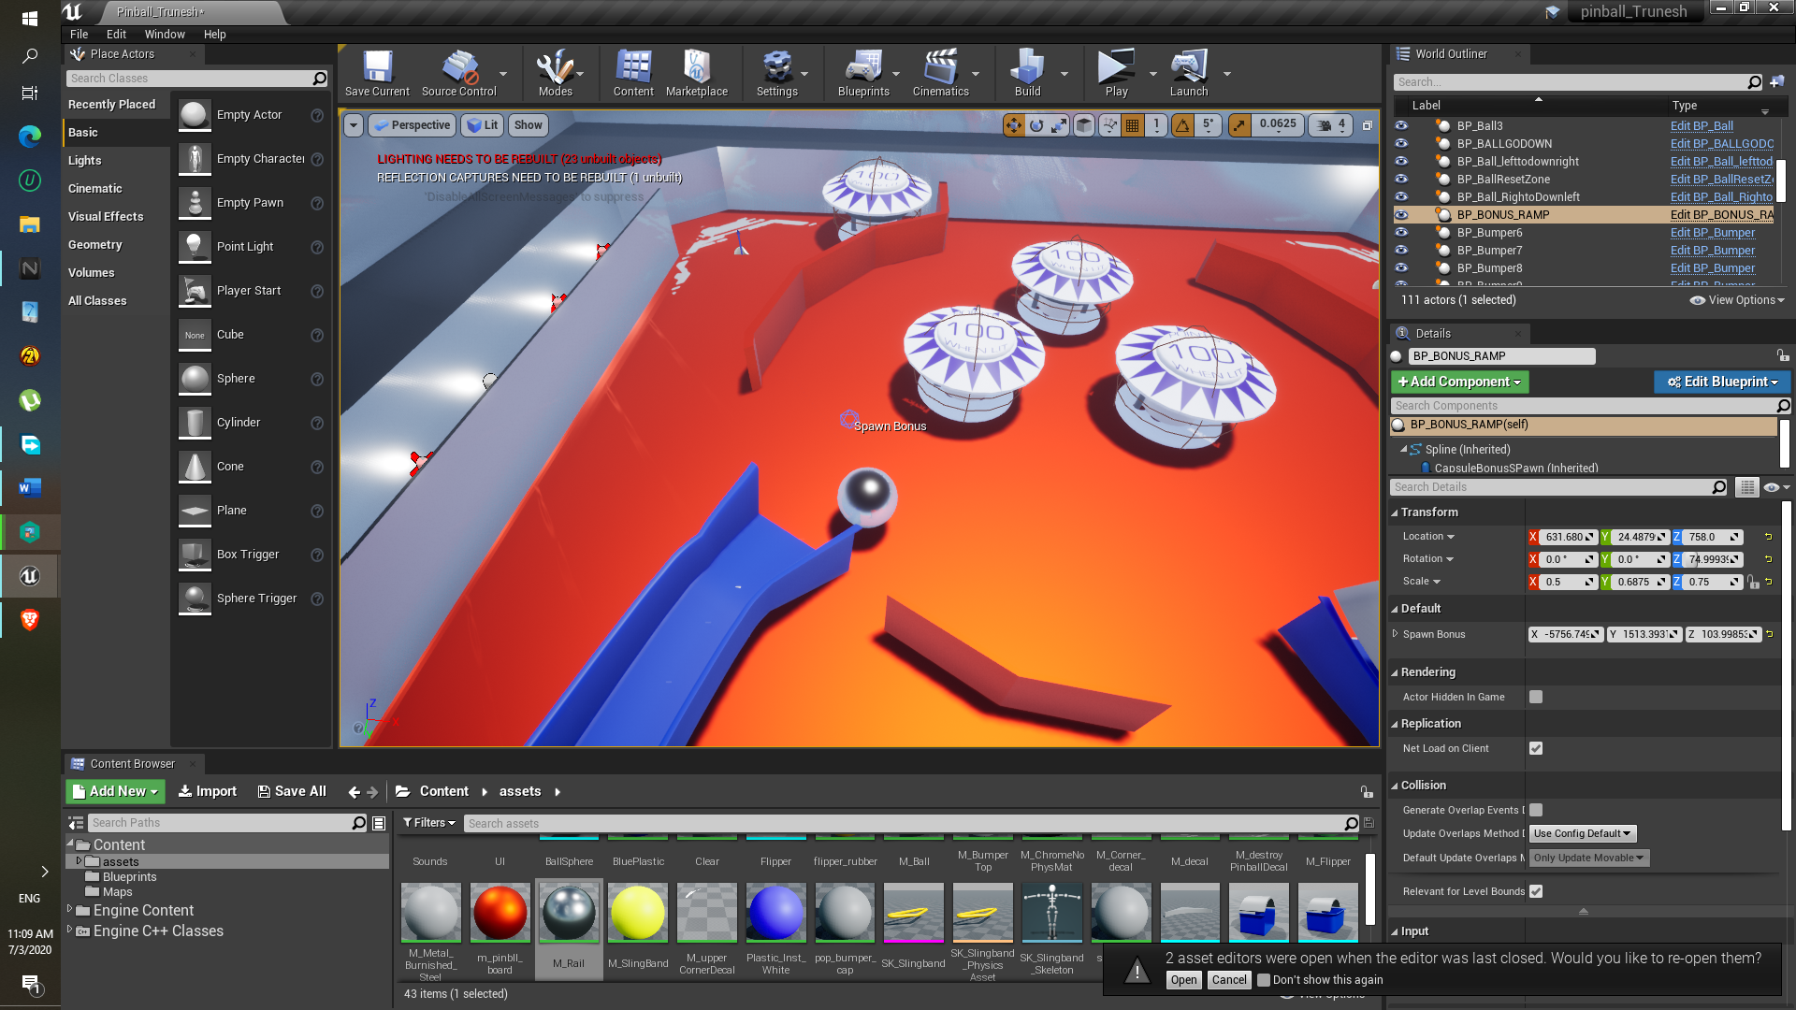

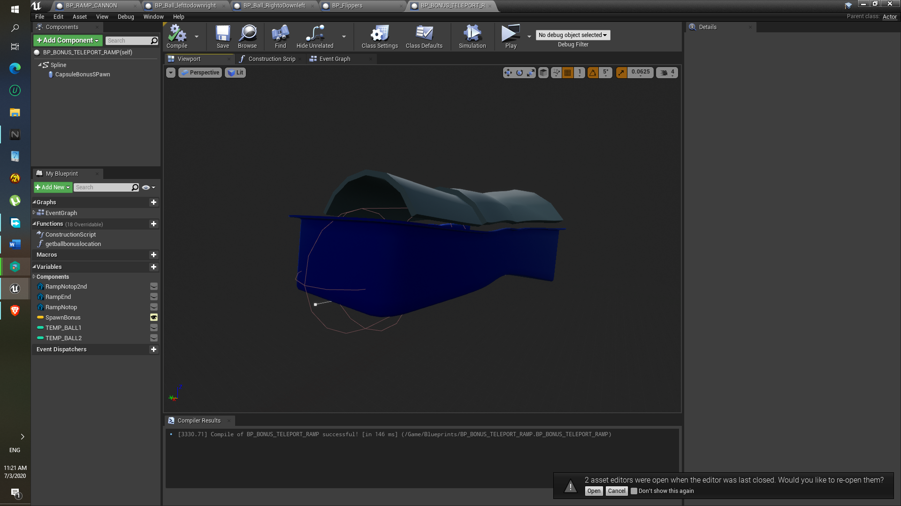

Approach:

1. This region is also made using the ramp blueprint class.
2. In this BP_RAMP_TELEPORT_BONUS blueprint class, the collision overlap is added at the end part, and as shown in the top most figure , the other spline points are deleted, as same with the cannon component.
3. As part of spawn location, it is placed manually, yeah by dragging it.
4. This event graph is made using via help of the plunger blueprint.
5. These components help to spawn the ball at “Spawn Bonus” position

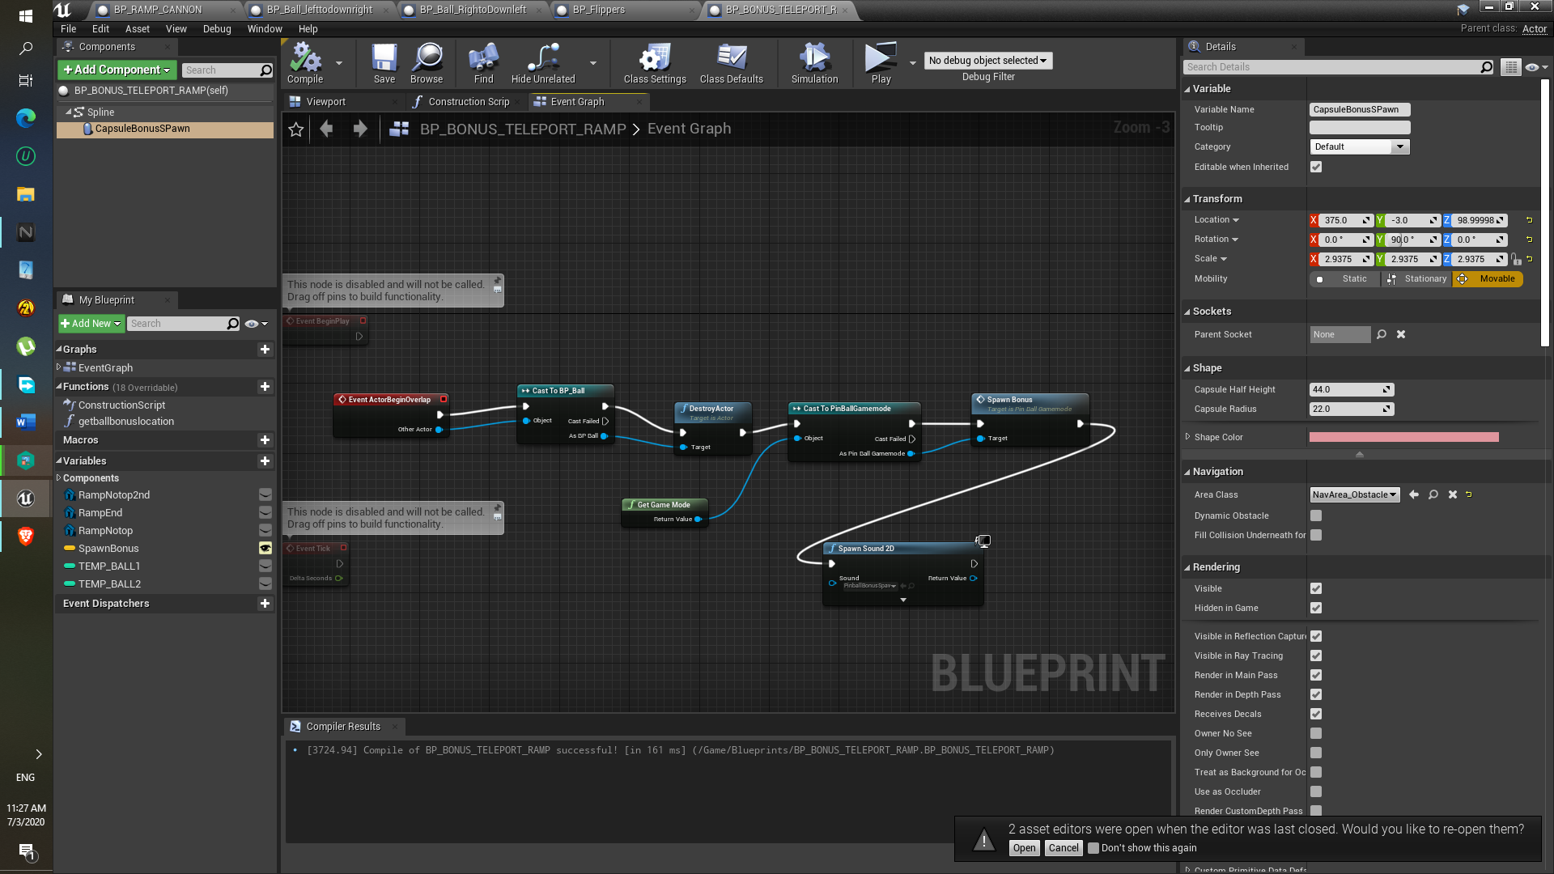

Difficulty:

Well I actually tried that get ball location of my own, like using some component “get world location” or something I can’t recall, but I unable to get the “spawn bonus “( Instance 3d widget ) location, so in the end I just used the BP_Plunger class Function “get ball location” help to get the “spawn Bonus” 3d widget location and get Actor transform.

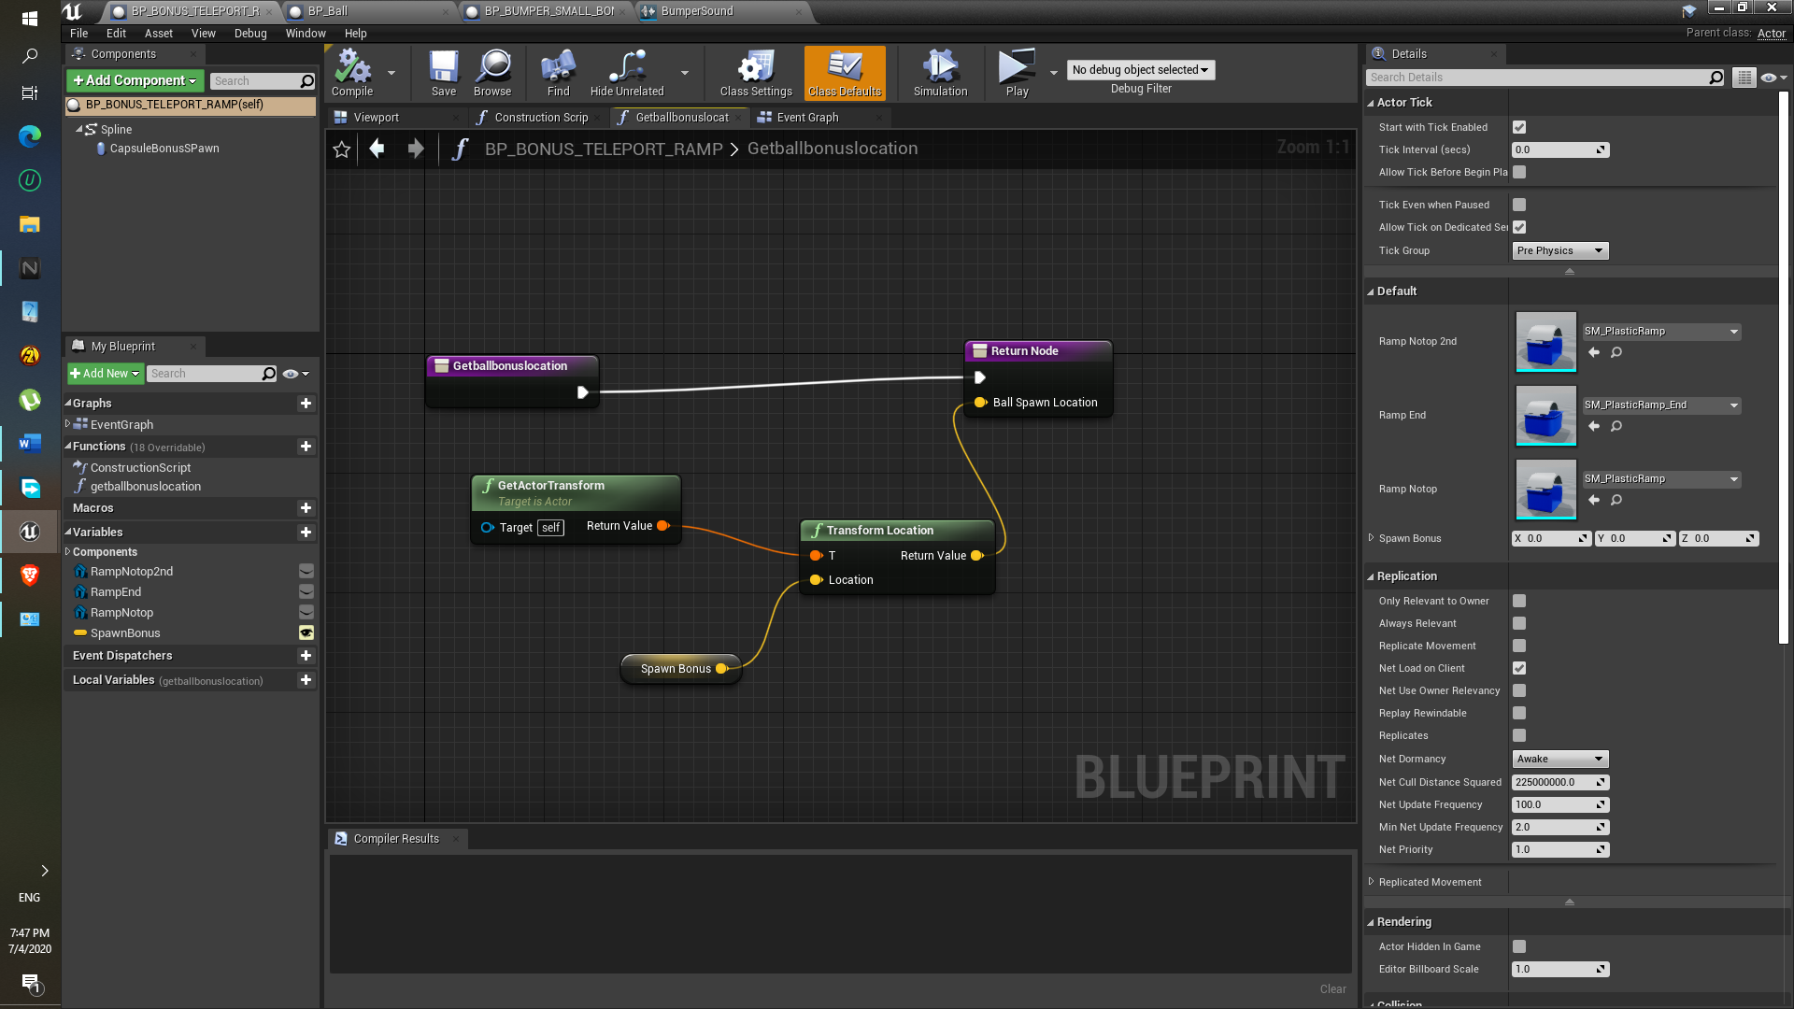

**Component: Plunger**

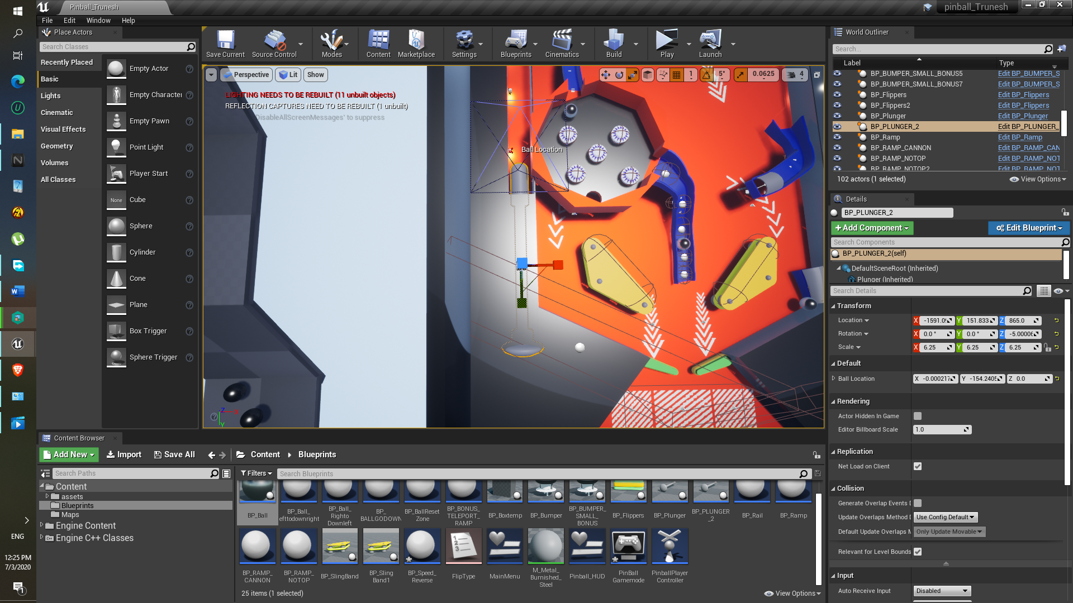

Approach:

1. Plunger should be move backwards after pressing and hold Spacebar.
2. That’s why the timeline is used.

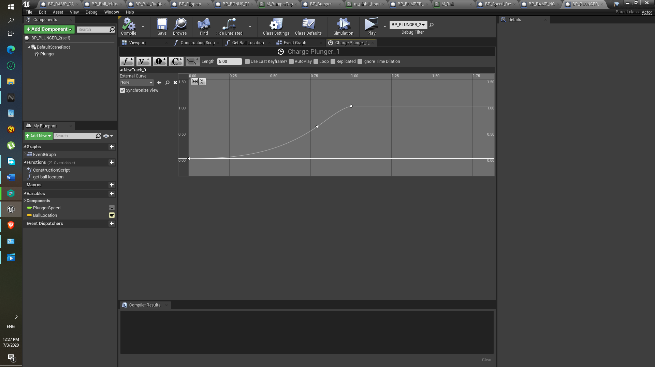

1. In project settings and in “input” is specified using action mapping feature, space is assigned for the plunger movement.

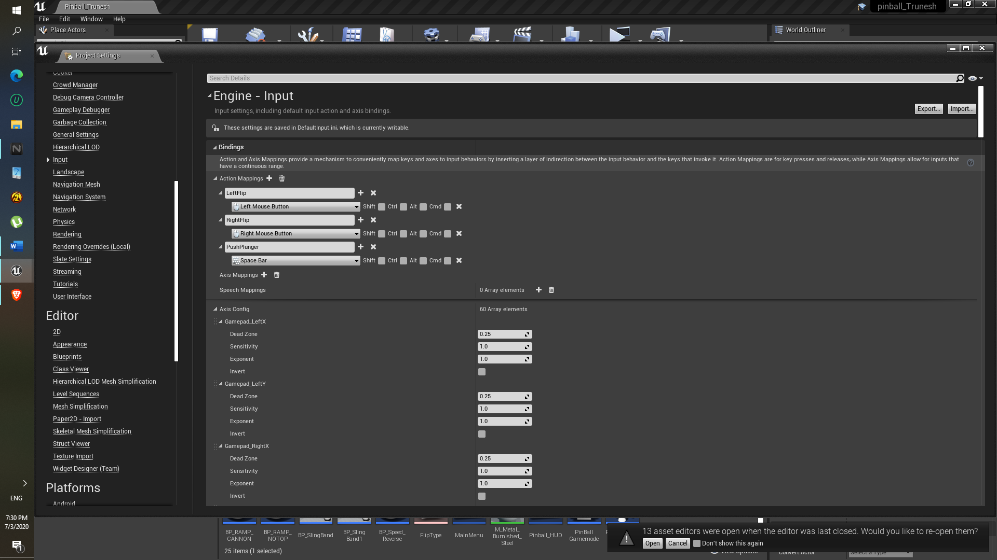

1. In event graph the lerp is used so that, the plunger will move back from its original position to the specified position at given above timeline.

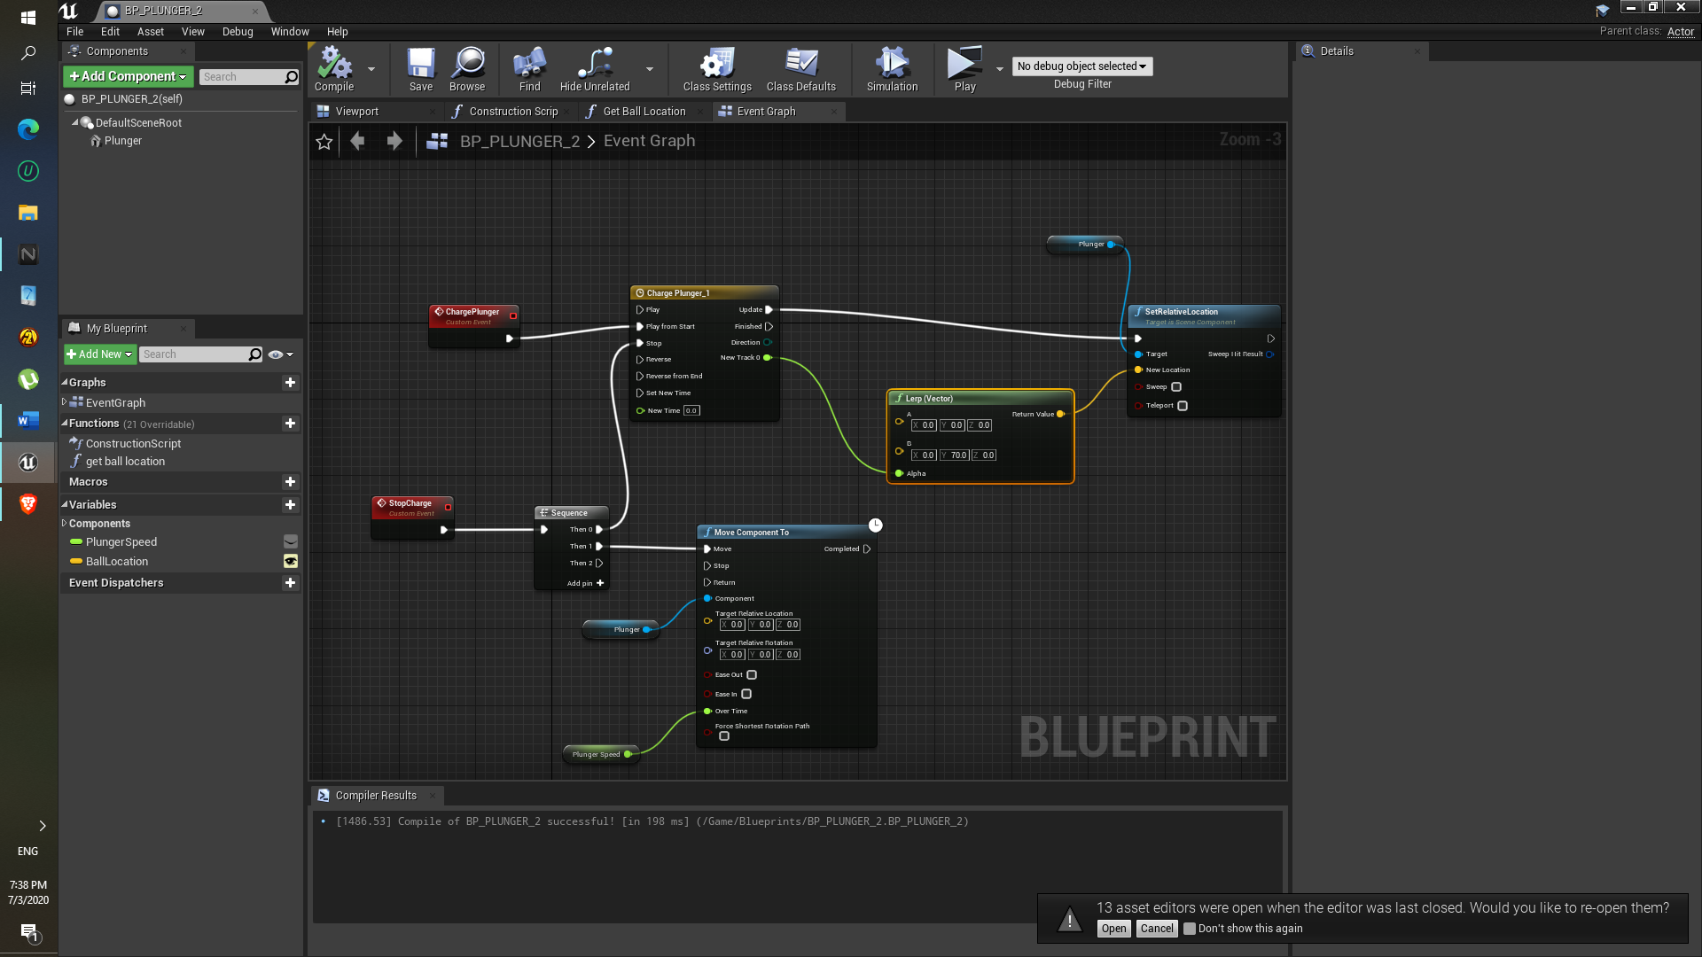

1. As soon as spacebar is released the move component will move plunger to its original position.
2. Get ball location function is used to spawn the ball.
3. In pinball game mode the Spawn function is created, in that function the ‘Spawn actor from class’ is used to spawn the actor at particular transform/ position, that component uses ‘Get ball location’.

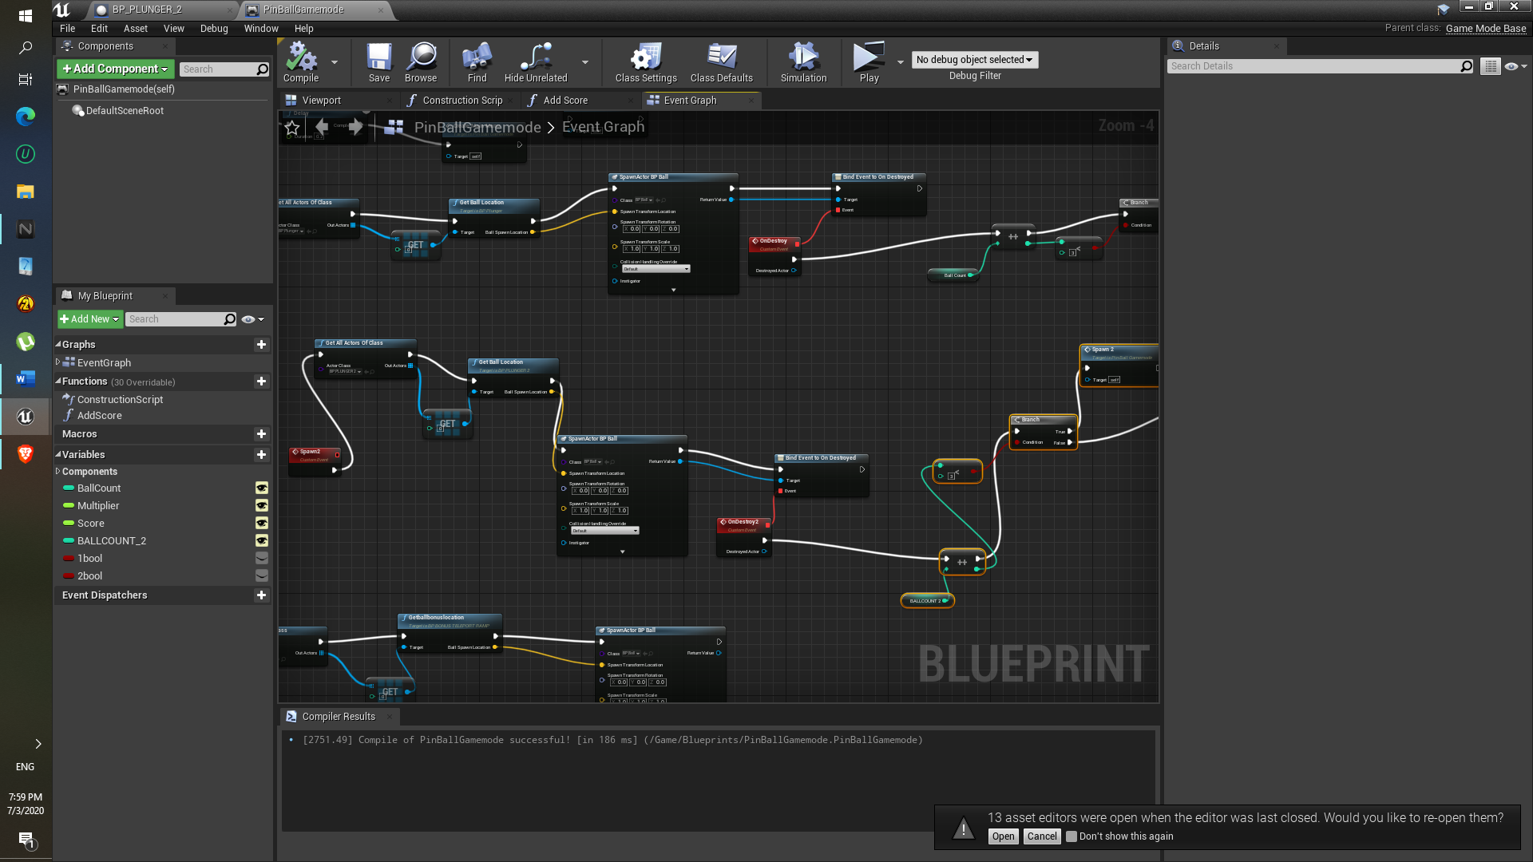

1. To end the game, I simply added to Booleans and check them after getting ball count upto 3. For both plunger that means total 6 balls.

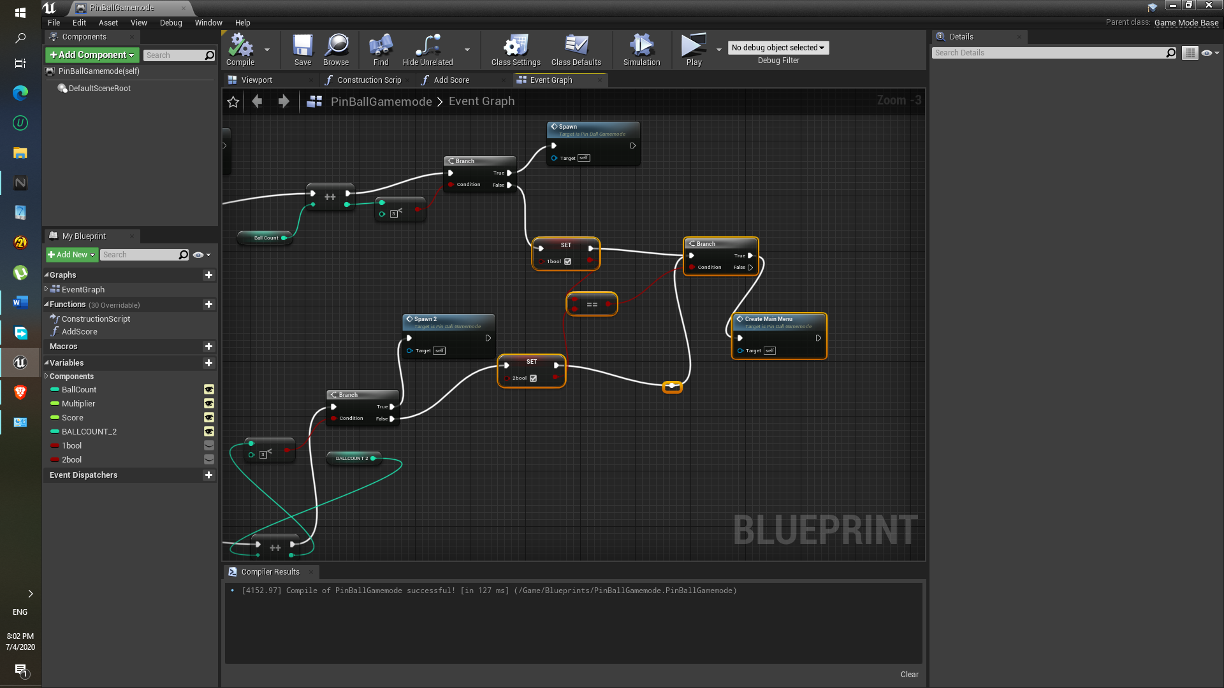

9)Added sounds to the when plunger is charge, that is when Spacebar is hold and when it is released.

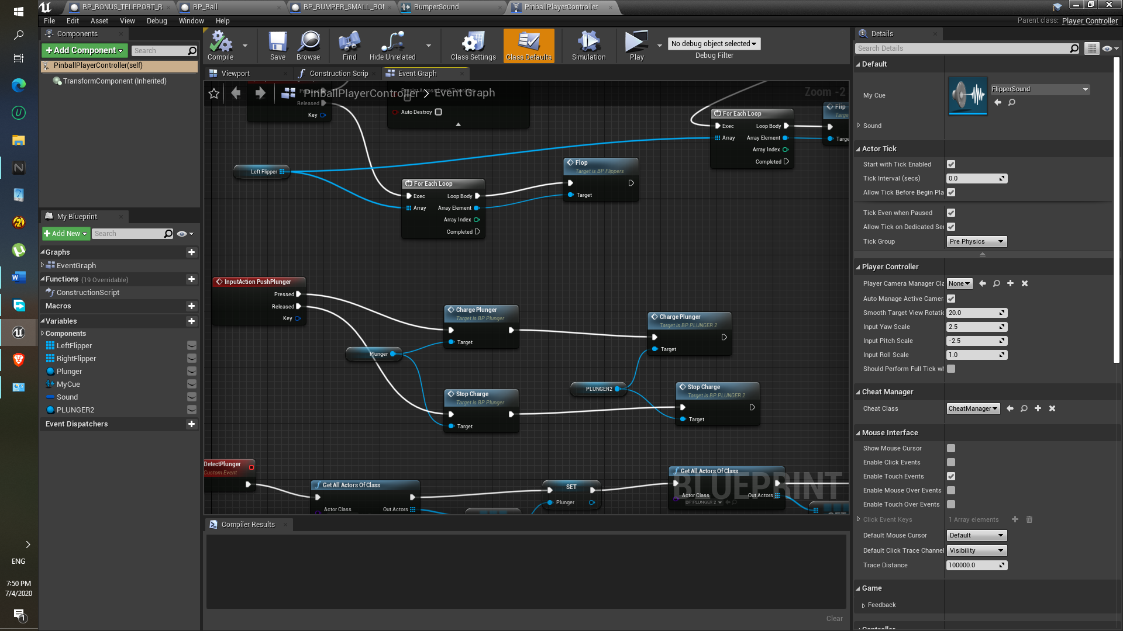

Difficulty:

Plunger was flying off for some reason, later I realized that we have to disable the Simulate physics. So, it won’t fly off.

**Component: Side Ramp**

Approach:

1. This is also develop using the Rail blueprint.
2. Static mesh Rail mid, Rail End, Rail mouth are replace with mouth_plastic ramp, Notop_ramp, Ramp_End static mesh

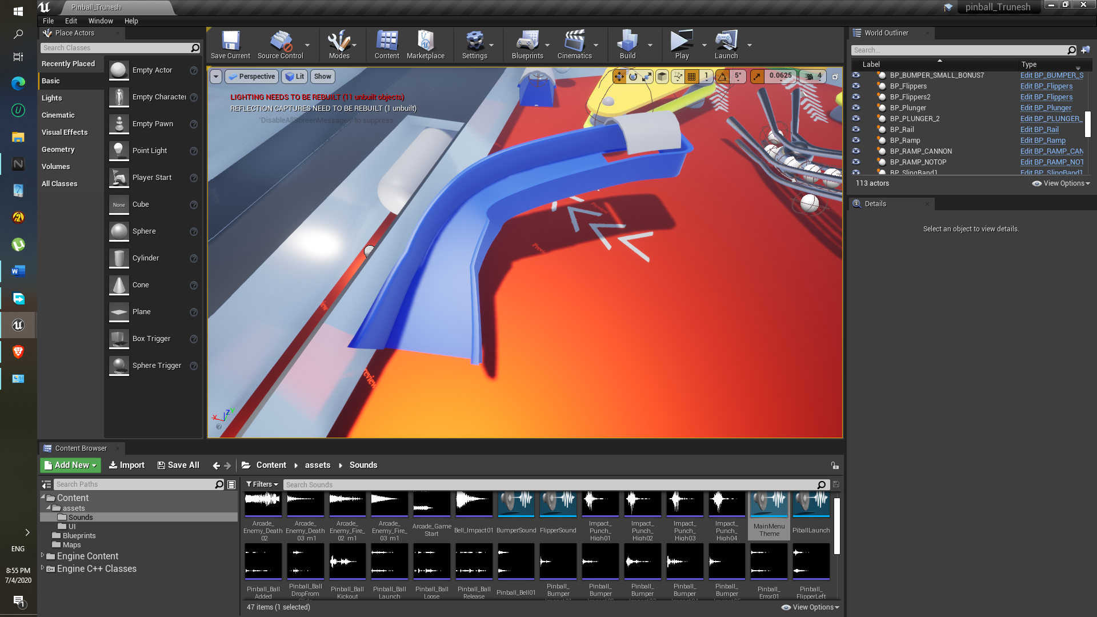

Difficulty: None

**Component: Table frame**

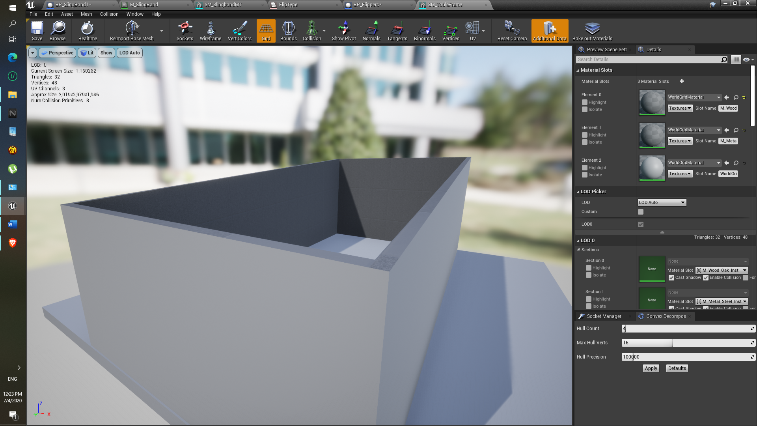

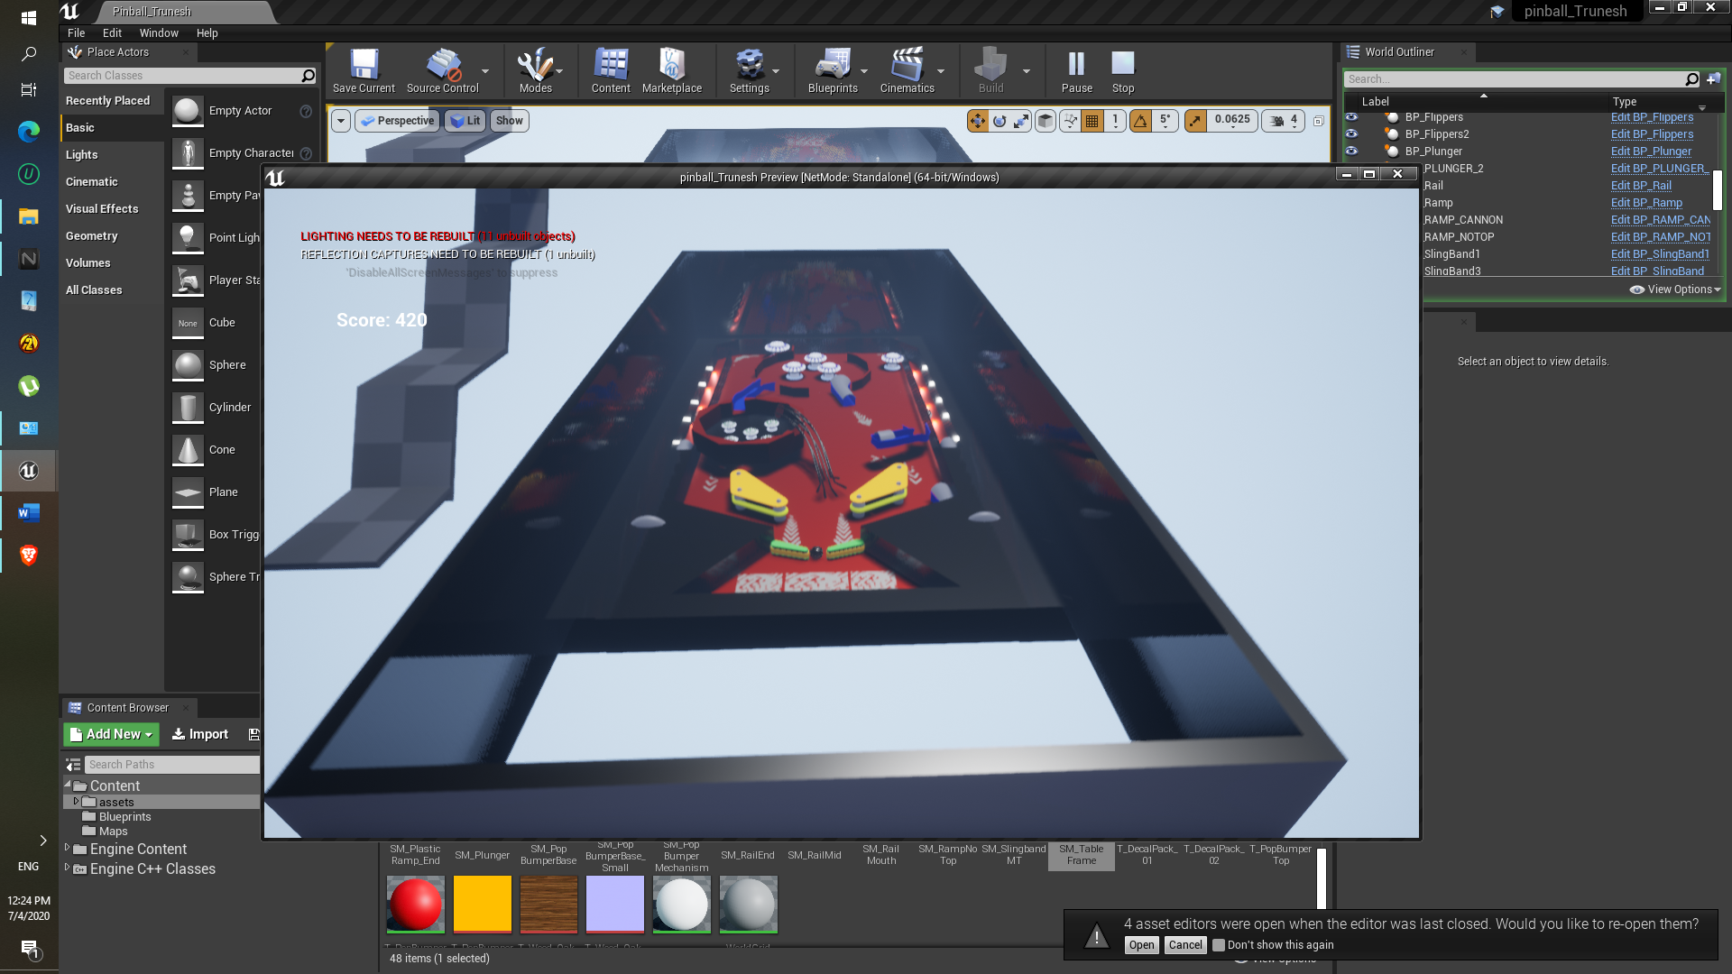

Approach :

1. Static mesh directly imported from the pinball assets.
2. Added collision in the static mesh editing using convex decompose

Difficulty: None

**Component: Plunger Ball Path, Plunger locations and Lights etc.**

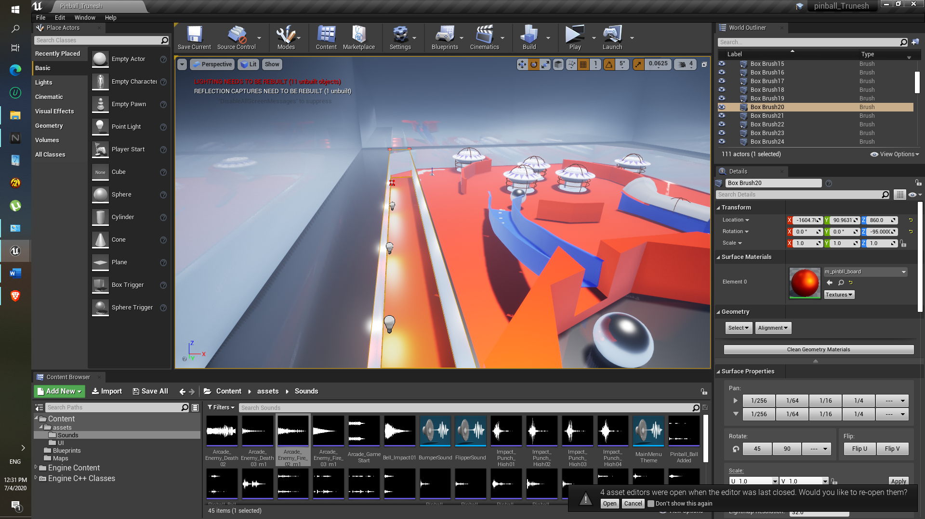

Approach:

1. Ball has to pass through that region, so the Subtractive geometry box is used.
2. Point lights are added in path for more creative look.

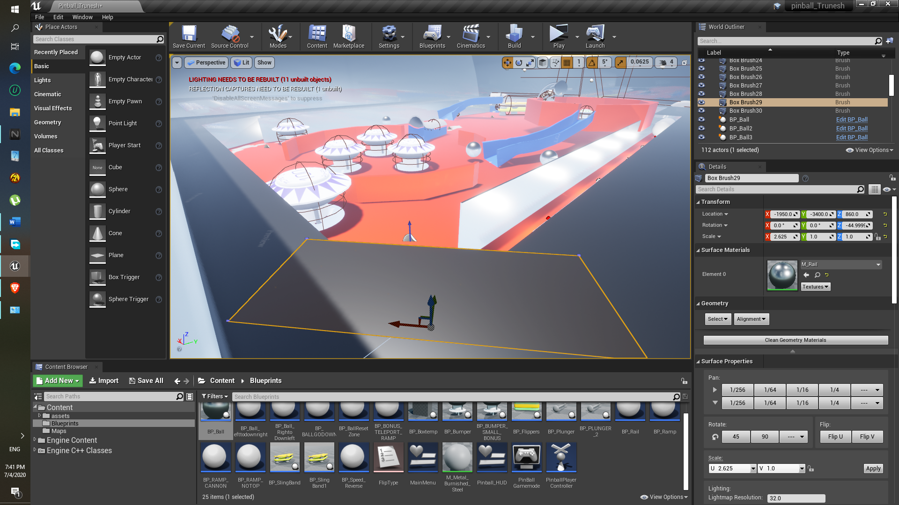

1. Another geometry box is added , So that after ball impacts on that box, it can get inside the main region of the pinball game.

**Component: Ball**

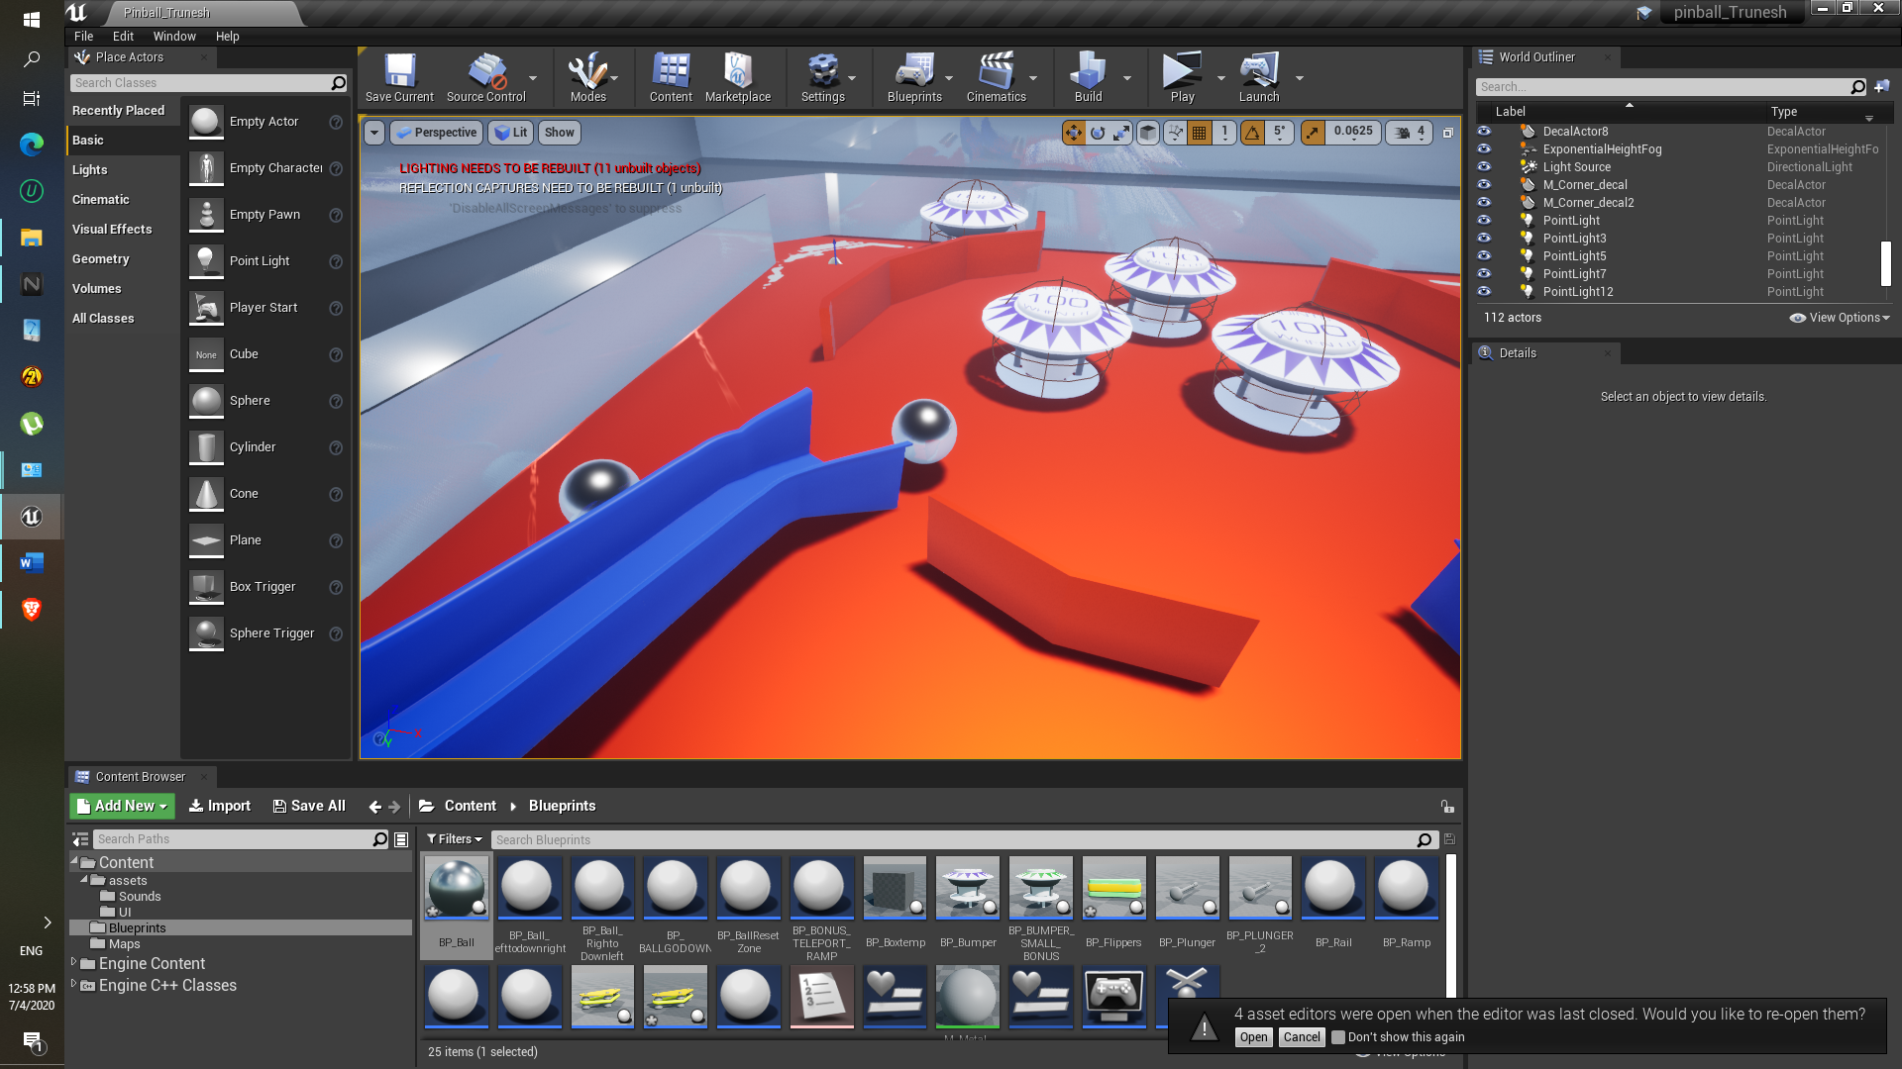

Approach:

1. Ball has to move in downward direction so the constant impulse is added in downward direction, in my case the +ve Y-axis.

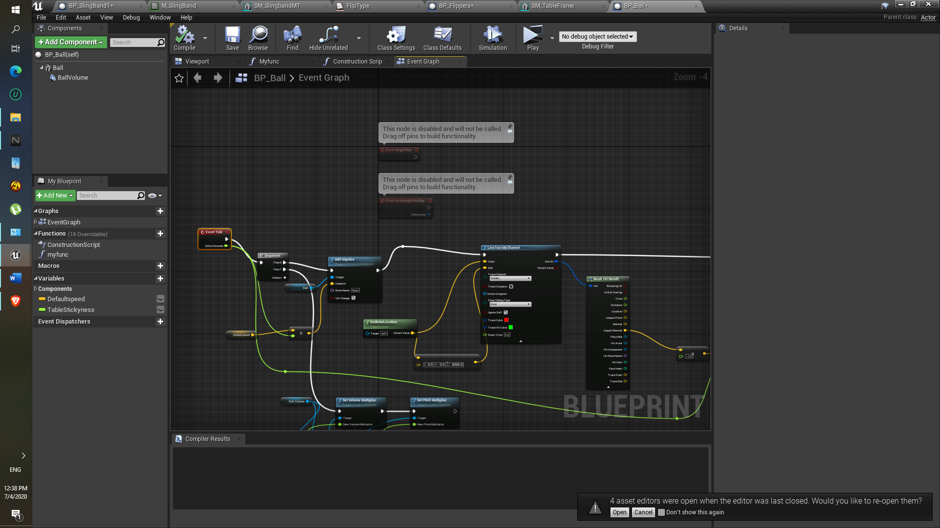

1. At each event tick ball will have the the downward direction speed.
2. Another component is used here which is the LinetraceByChannel.
3. In linetraceByChannel’s ‘Impact normal’ help the ball to stick to the ground.

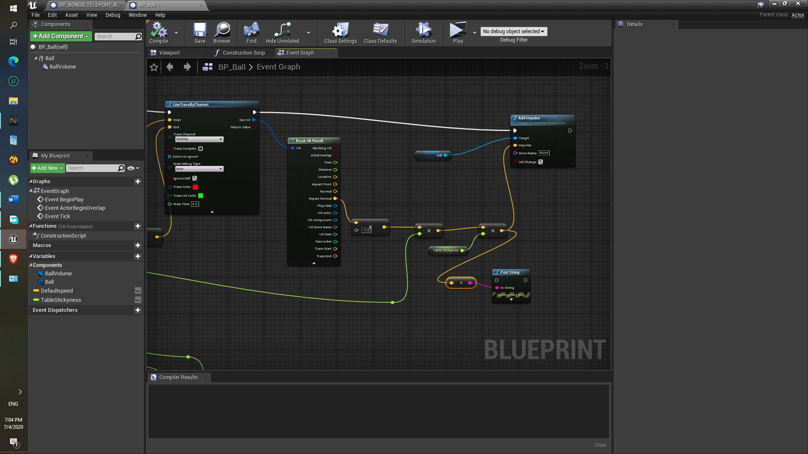

1. In above image the it is multiplied with -1 so that it will go downwards direction.
2. Event tick is multiplied with the vector because if the machine produce lag or something. it will keep ball at proper position.

Difficult: Ball still flies for some reason. If I increase stickiness, ball speed gets decreases and if flipper hits it, it goes slow in opposite direction because of flippers. That’s why I did not increase the table stickiness. Even now ball still flies off.

Additional Changes:

So fix that issue. I just added Empty blueprints in the Centre of the whole table frame and also two blueprints at the left and right side of the flipper.

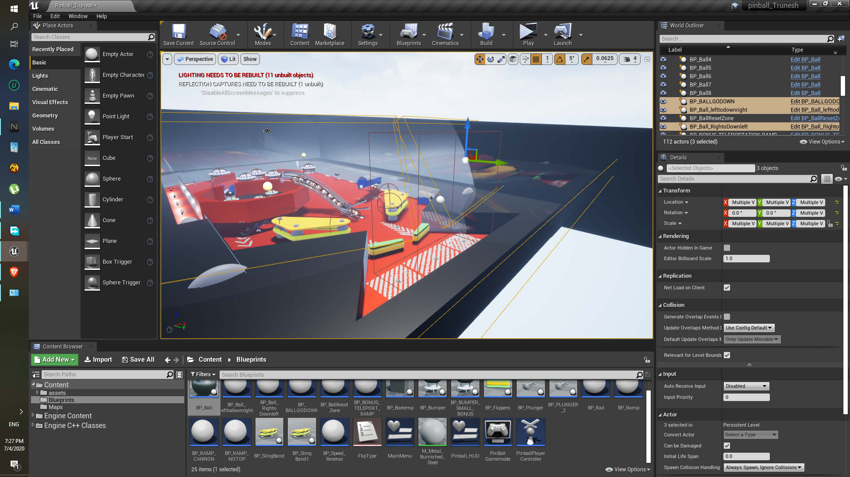

Both left- and right-hand side Blueprint box add impulse towards centre of the board, ball again gets inside the region.

**Component: Flippers Sound**

1. Approach here I used the single sound cue, so if we set parameter that sound will be played.

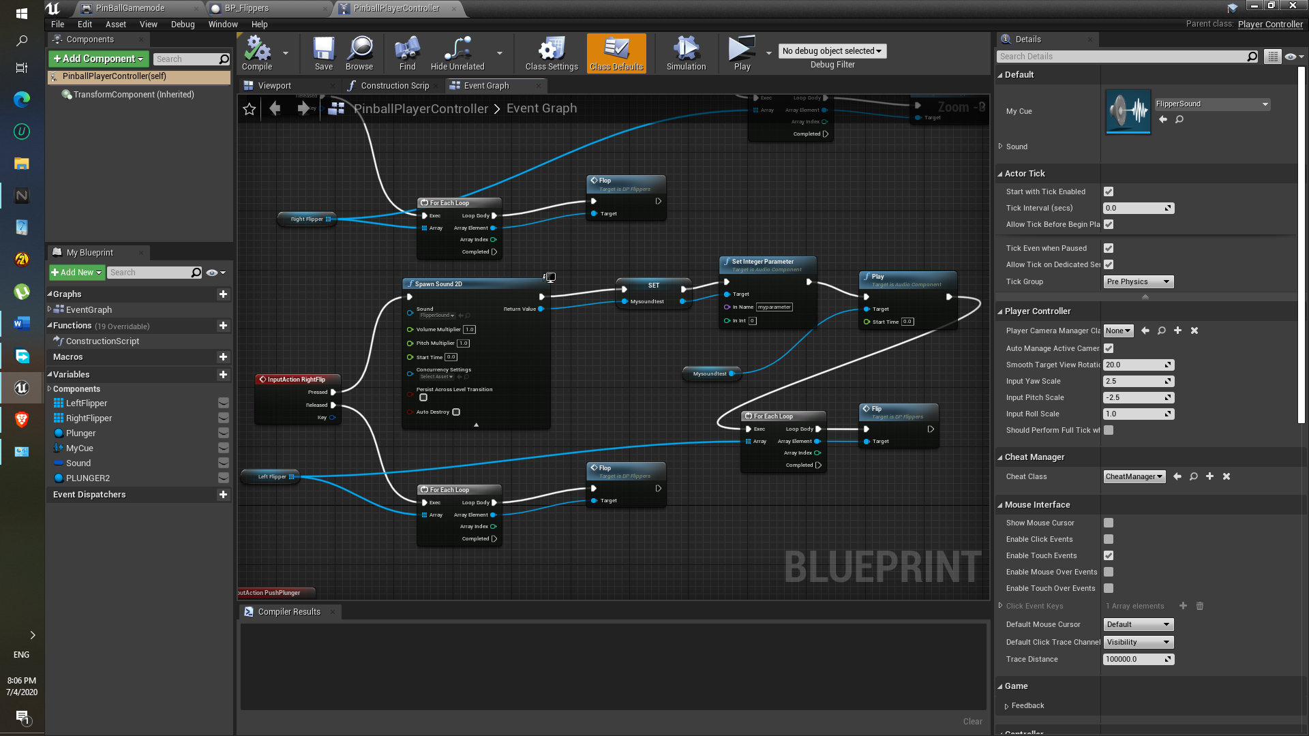

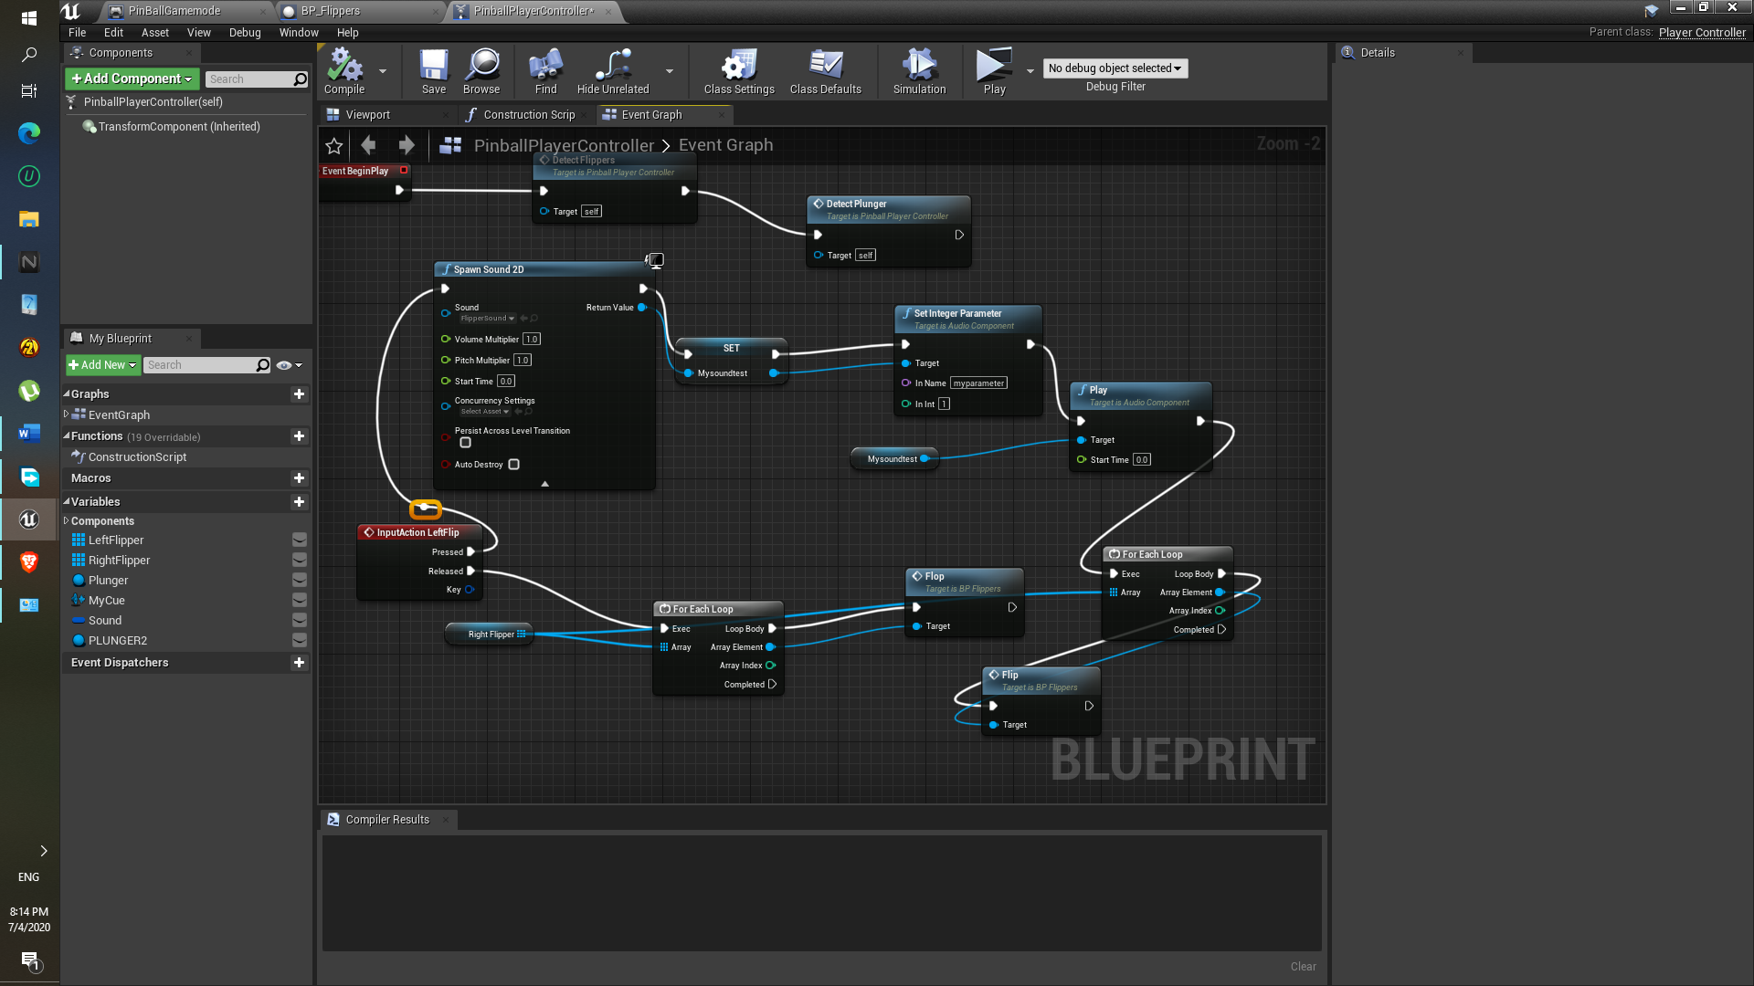

1. Here the Switch is added having unset,0,1 parameter ( unset and 0 has to be connected to the same sound else it wont work)

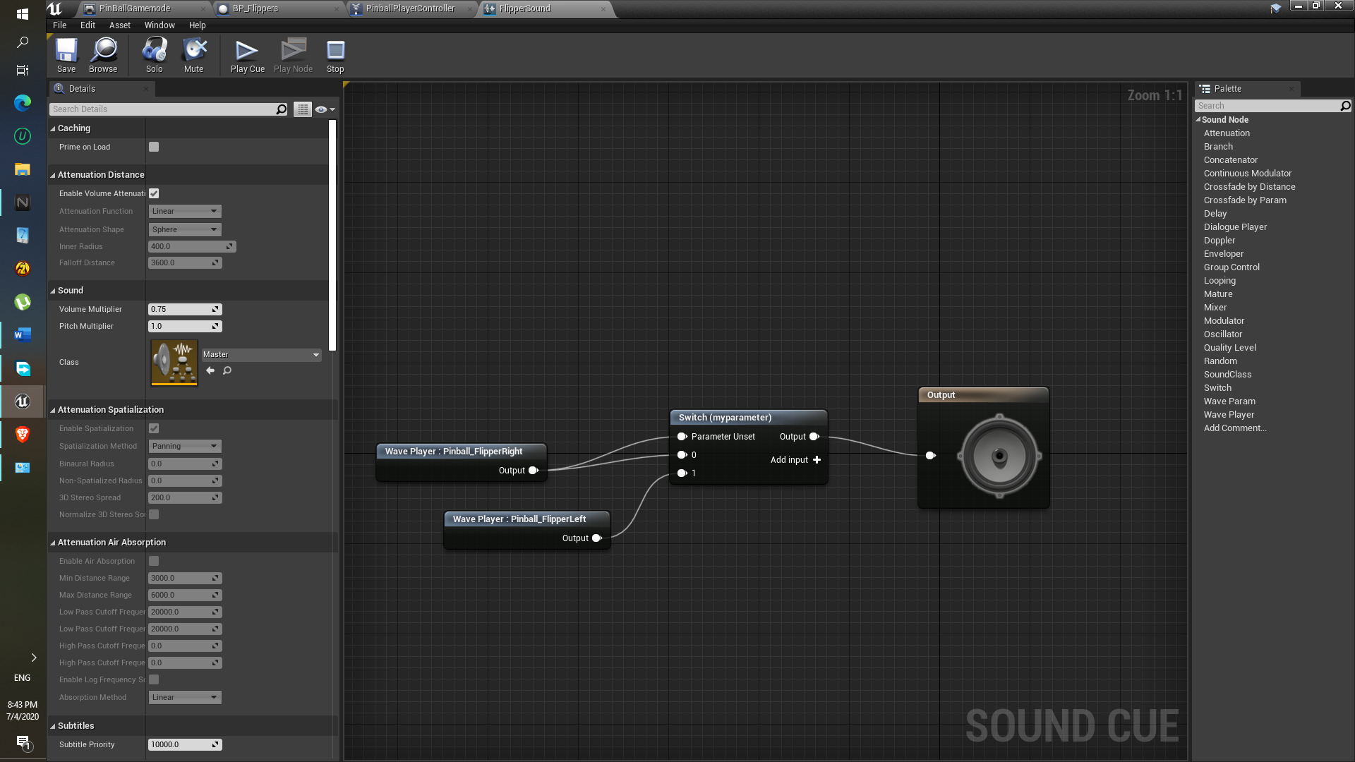

**Component : SlingBand Sound**

Approach:

1. Directly sounds are drag inside the sound cue.
2. Random is used… so that anyone of the sounds will be played.

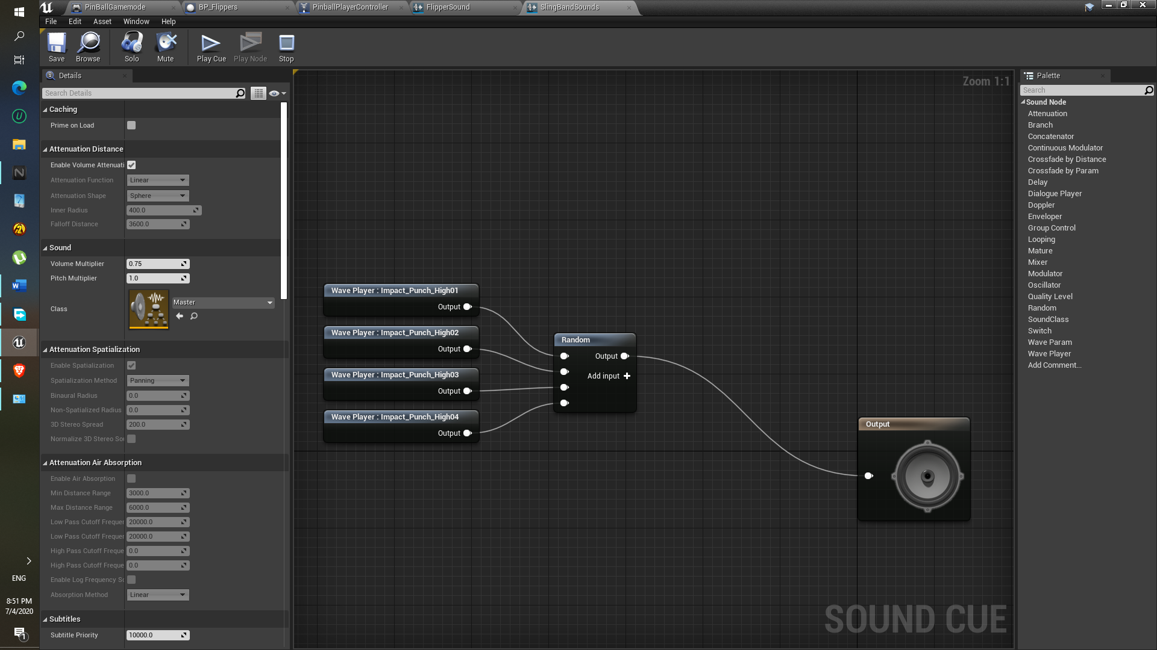

**Component : Main Menu Sound**

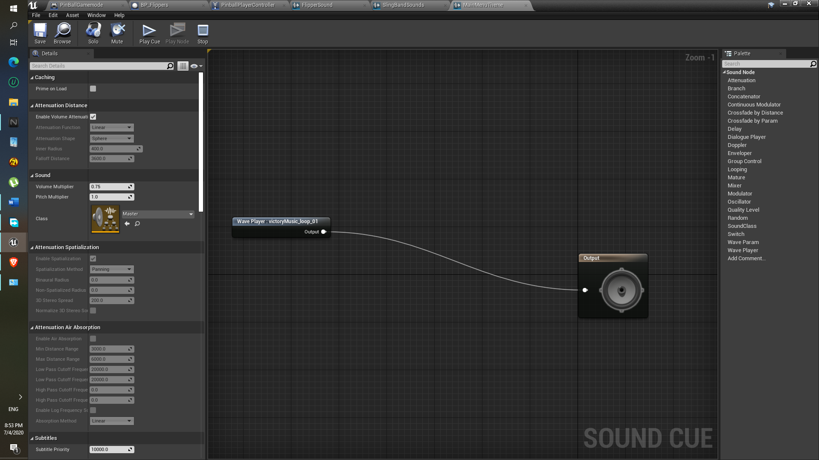

Approach:

1. Here sound will be played in a loop won’t stop.
2. As soon as played on play button , the Main menu theme sound component will be destroyed and the another sound PinballPlayStart will played.

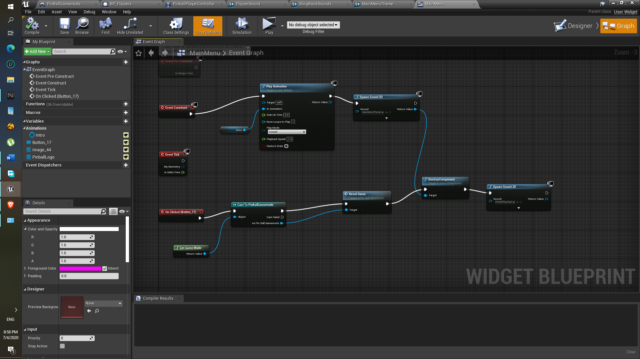

**Major bugs:**

1. Ball flies off, if I increase stickiness ball speed gets decreases.
2. Ball get spawn on plunger after getting inside the right side of the BONUS TELEPORT SPAWN BUT.. Also it won’t spawn the ball on the plunger 2nd time after that same ball goes in ball reset zone. It has to do with the Bind event on destroy.. The after ball getting destroyed. That bind event function gets run. I did tried to fixed using Boolean but nothing seems working.